Dataset: Abalone

*Distribution of features*

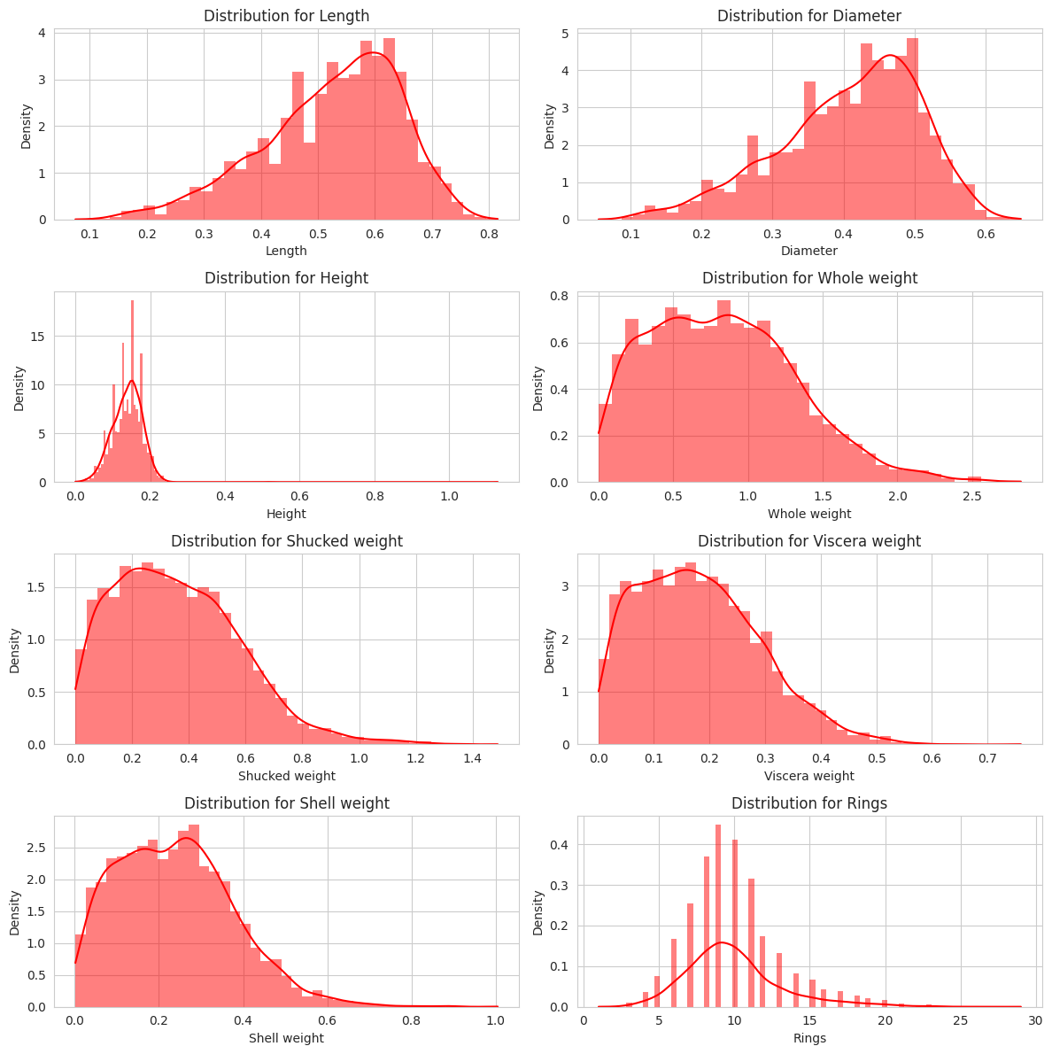

*Correlation*

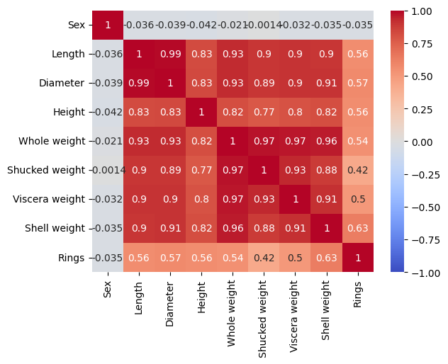

*Decision Tree*

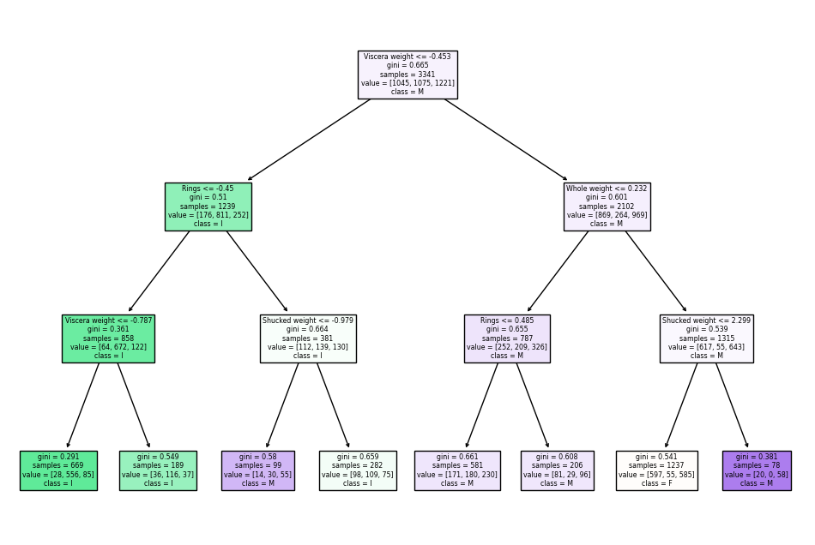

*Neural Network Training Accuracy & Loss*

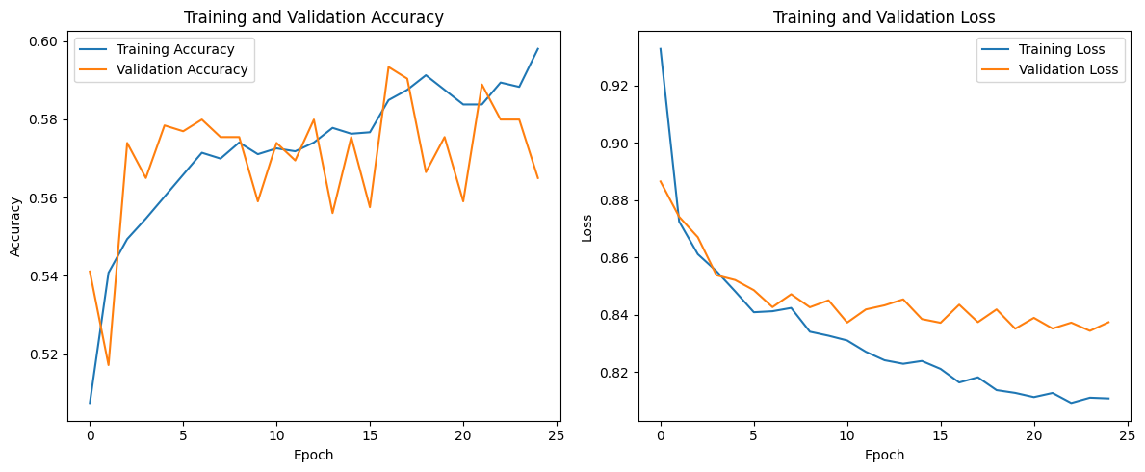

Accuracy increase and loss decrease over epoch

*ROC Curve*

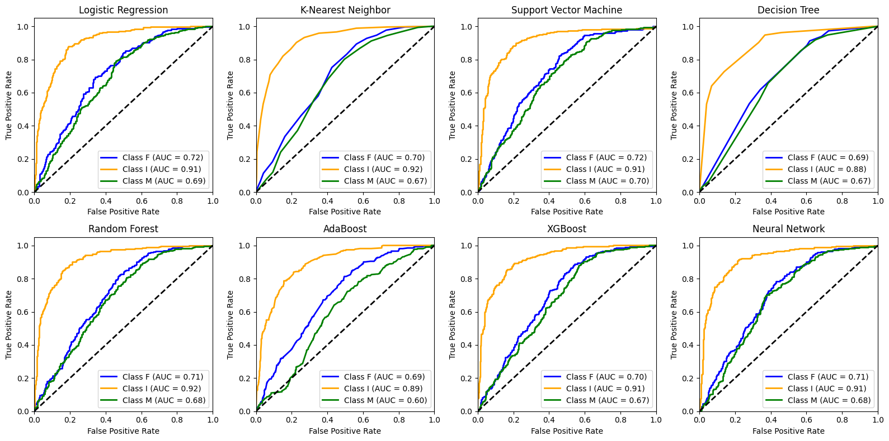

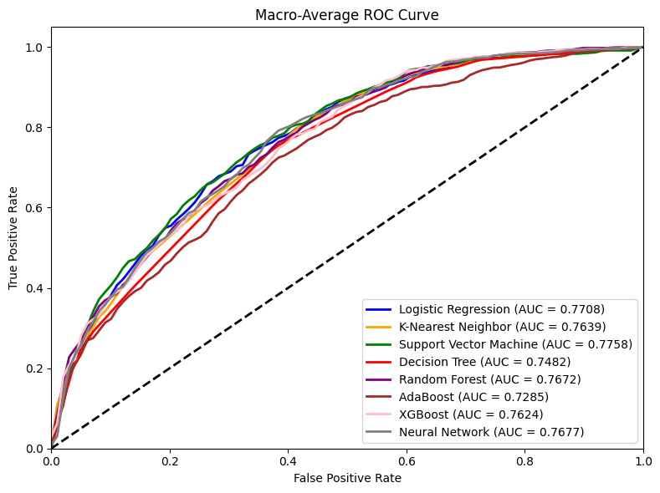

Similar AUC. SVM has the highest ROC AUC score

*LIME*

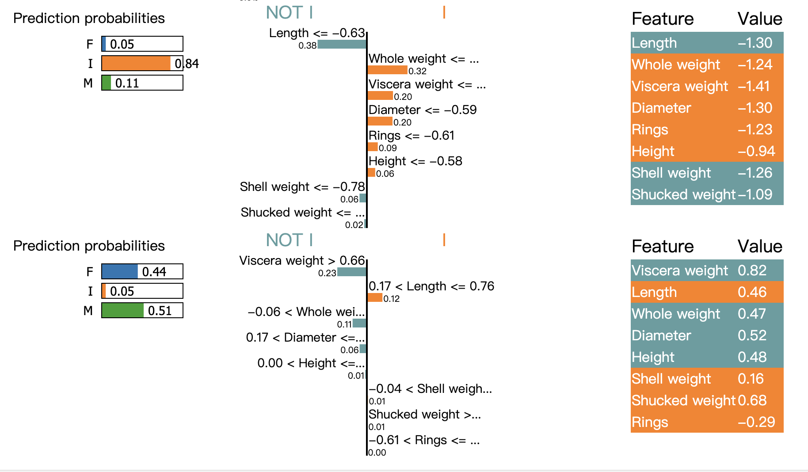

Feature importance by LIME

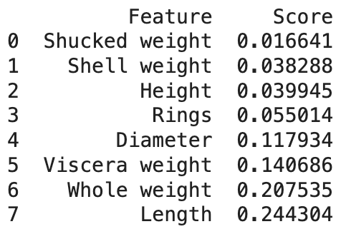

*SHAP*

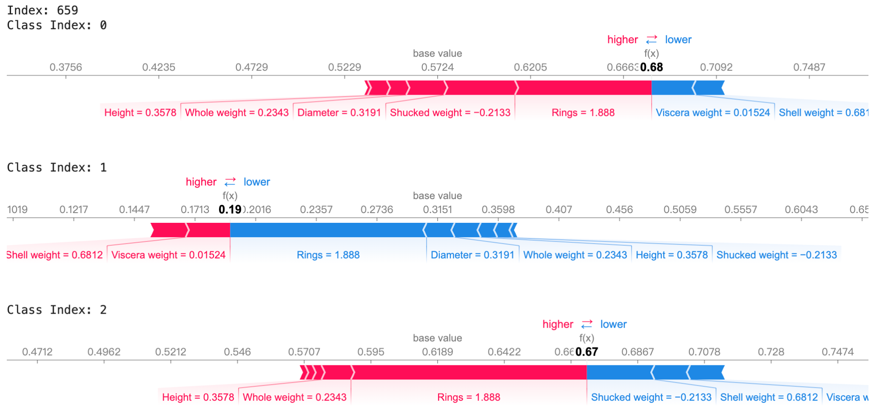

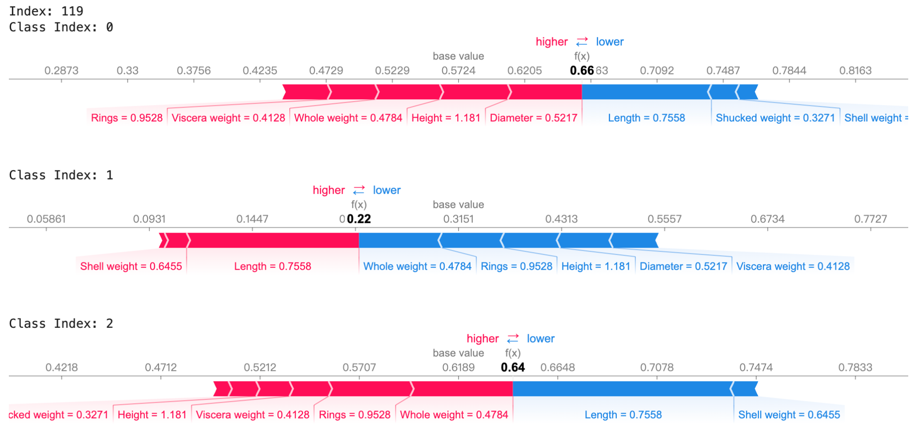

Feature importance by SHAP

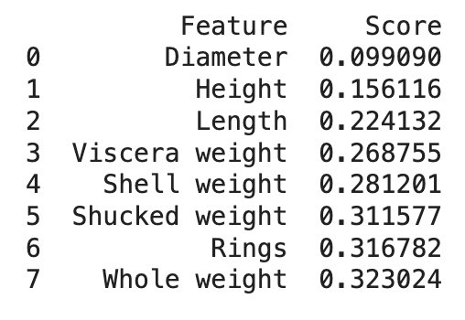

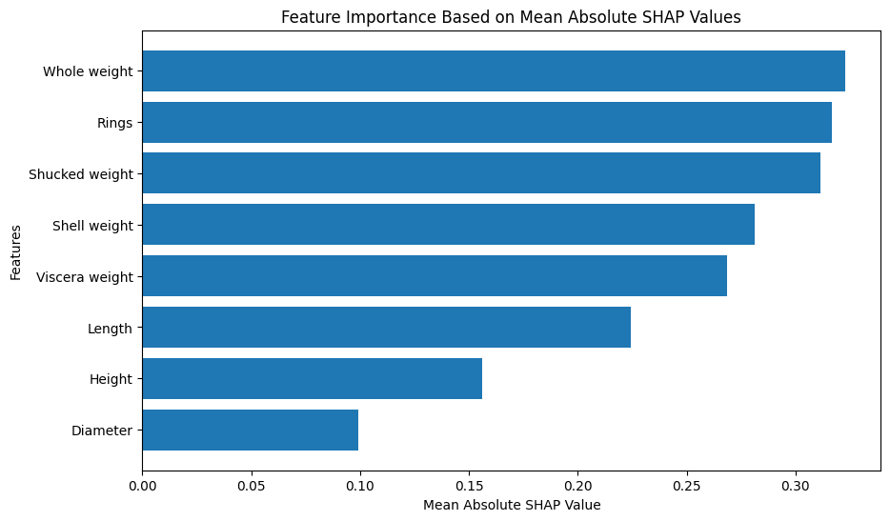

Summary plot

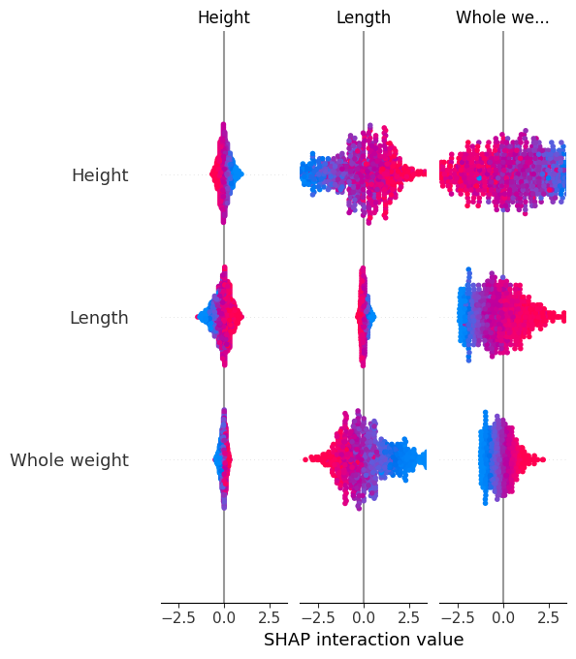

*ROC Curve (After LIME & SHAP)*

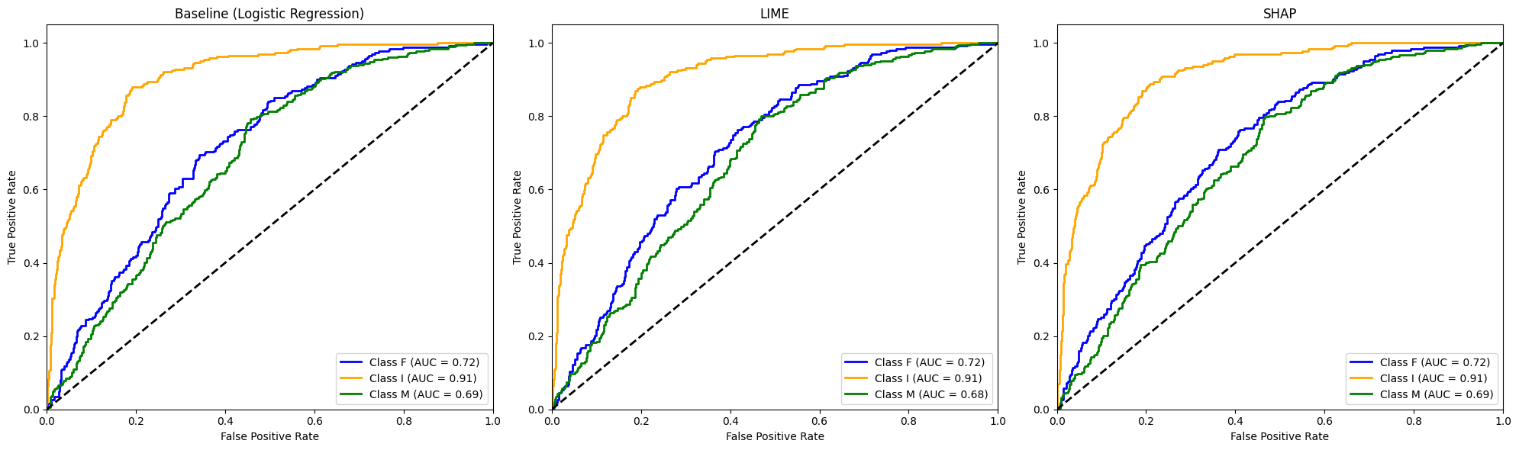

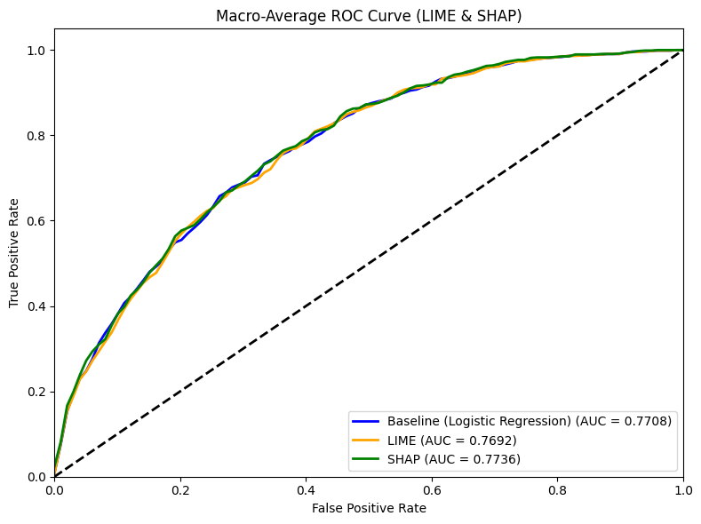

Dataset: BA

**BA Lime:**

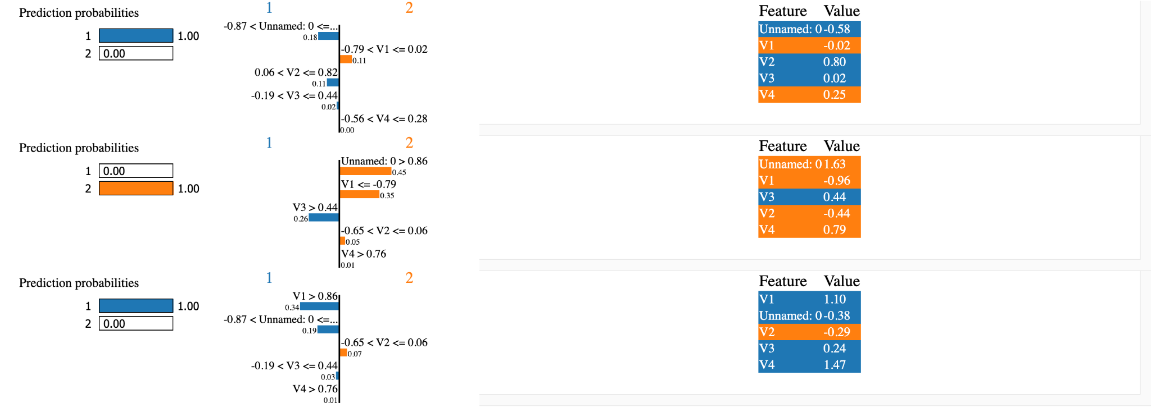

**BA Shap:**

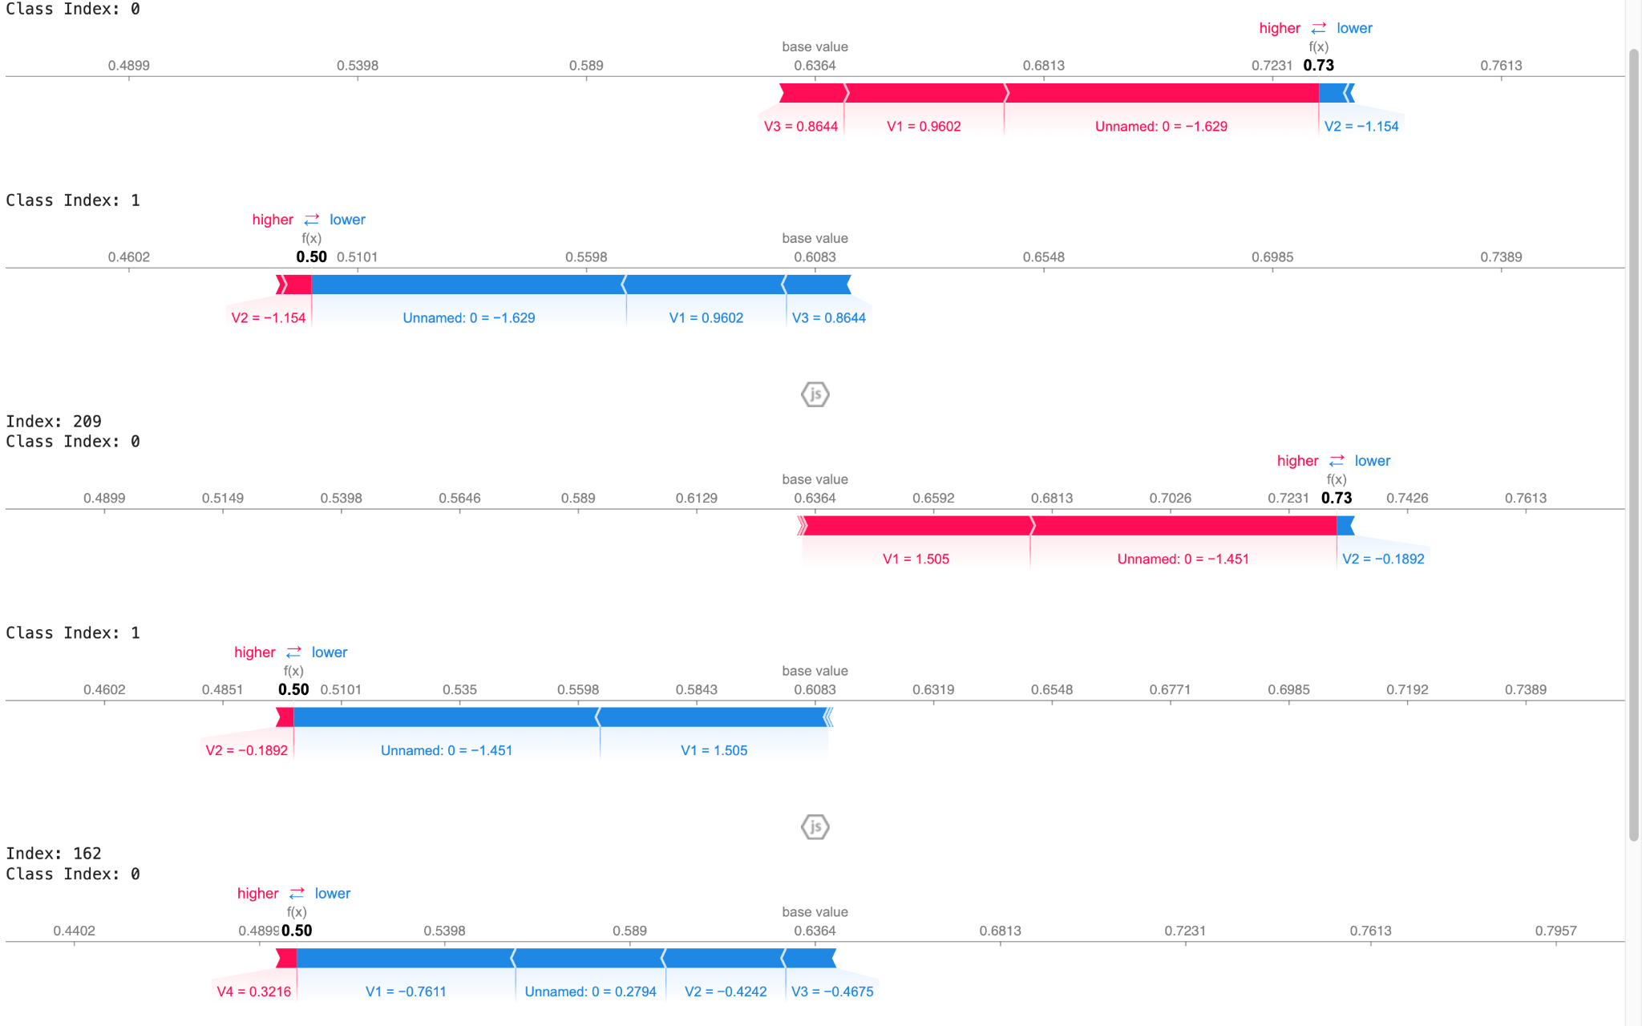

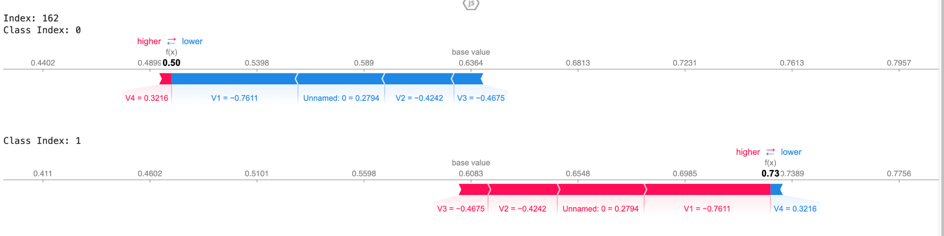

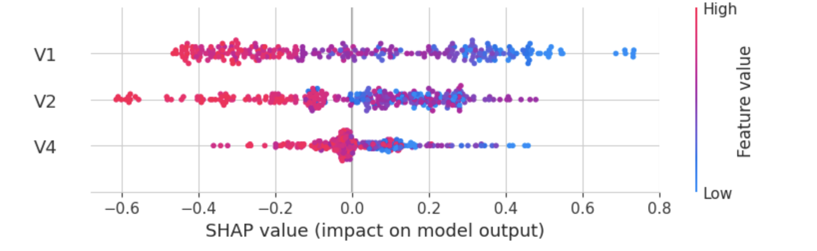

Dataset: iris

**Iris Lime:**

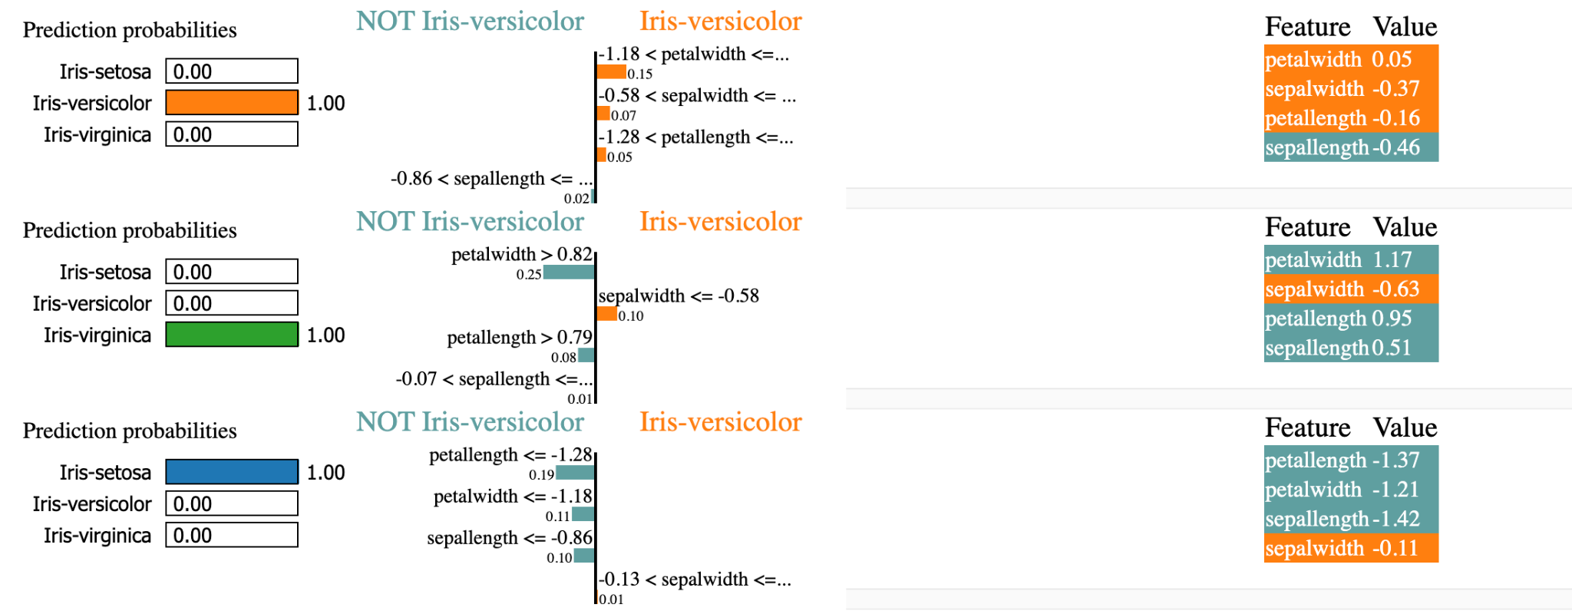

**Iris Shap:**

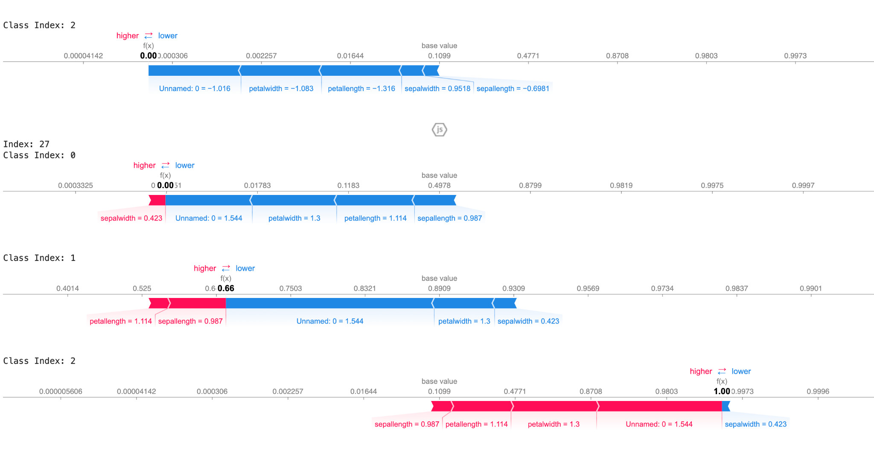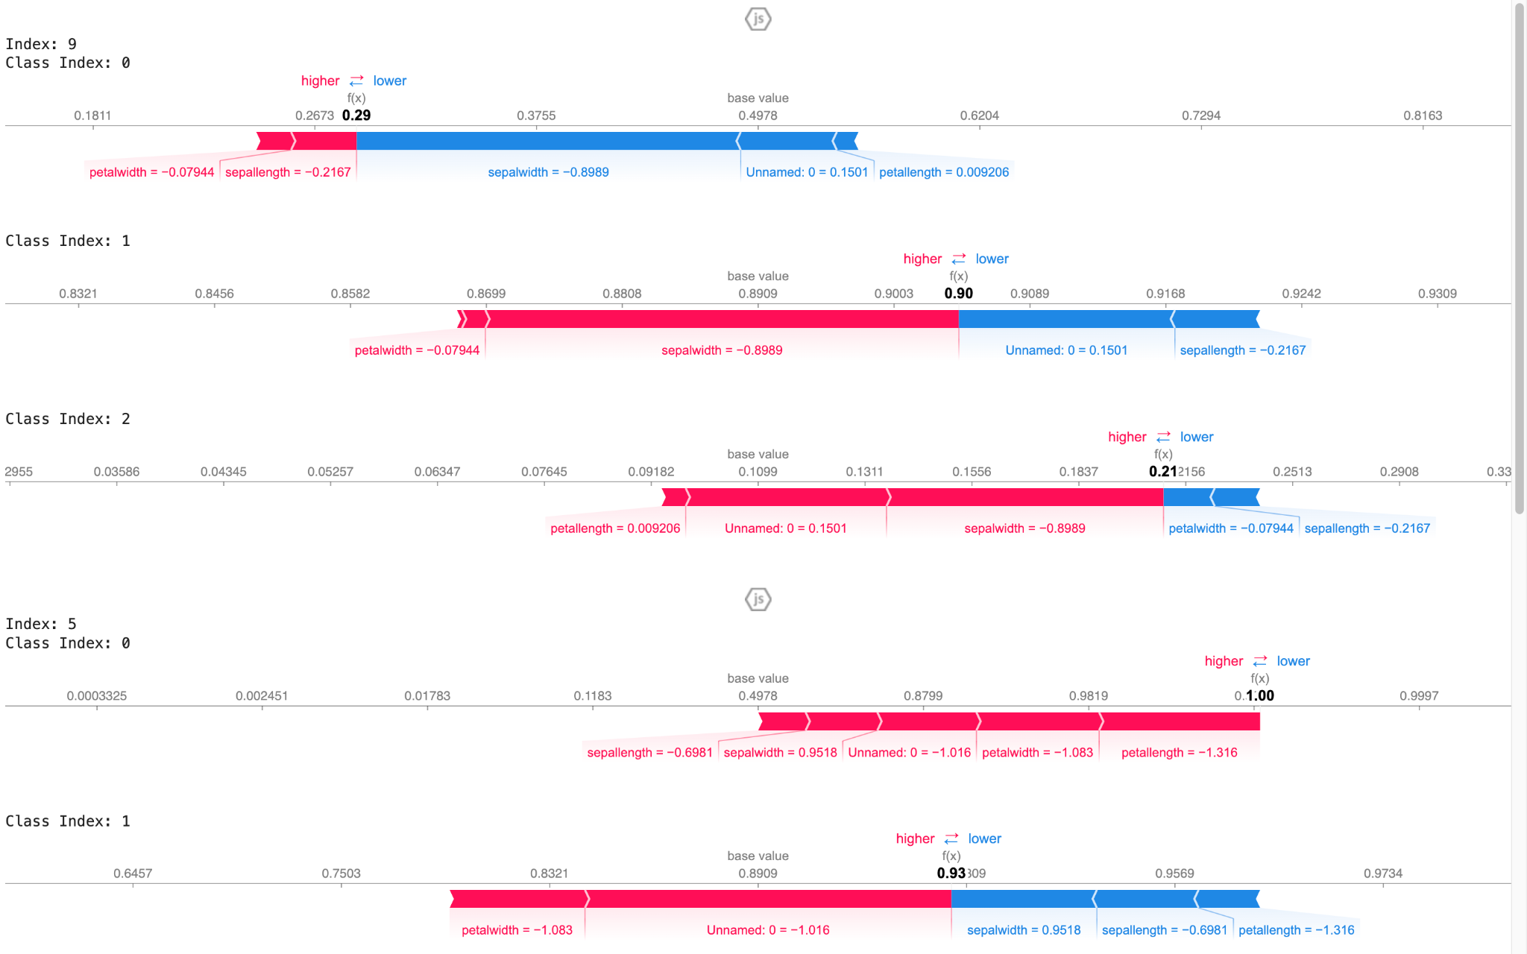

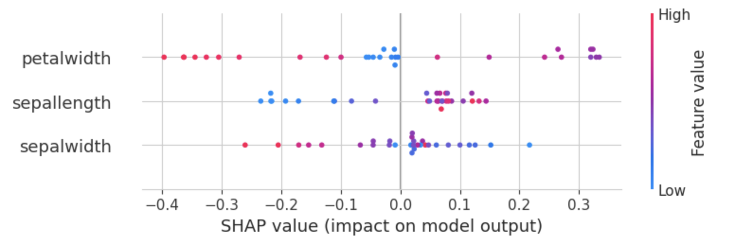

Dataset: credit

**Credit Lime:**

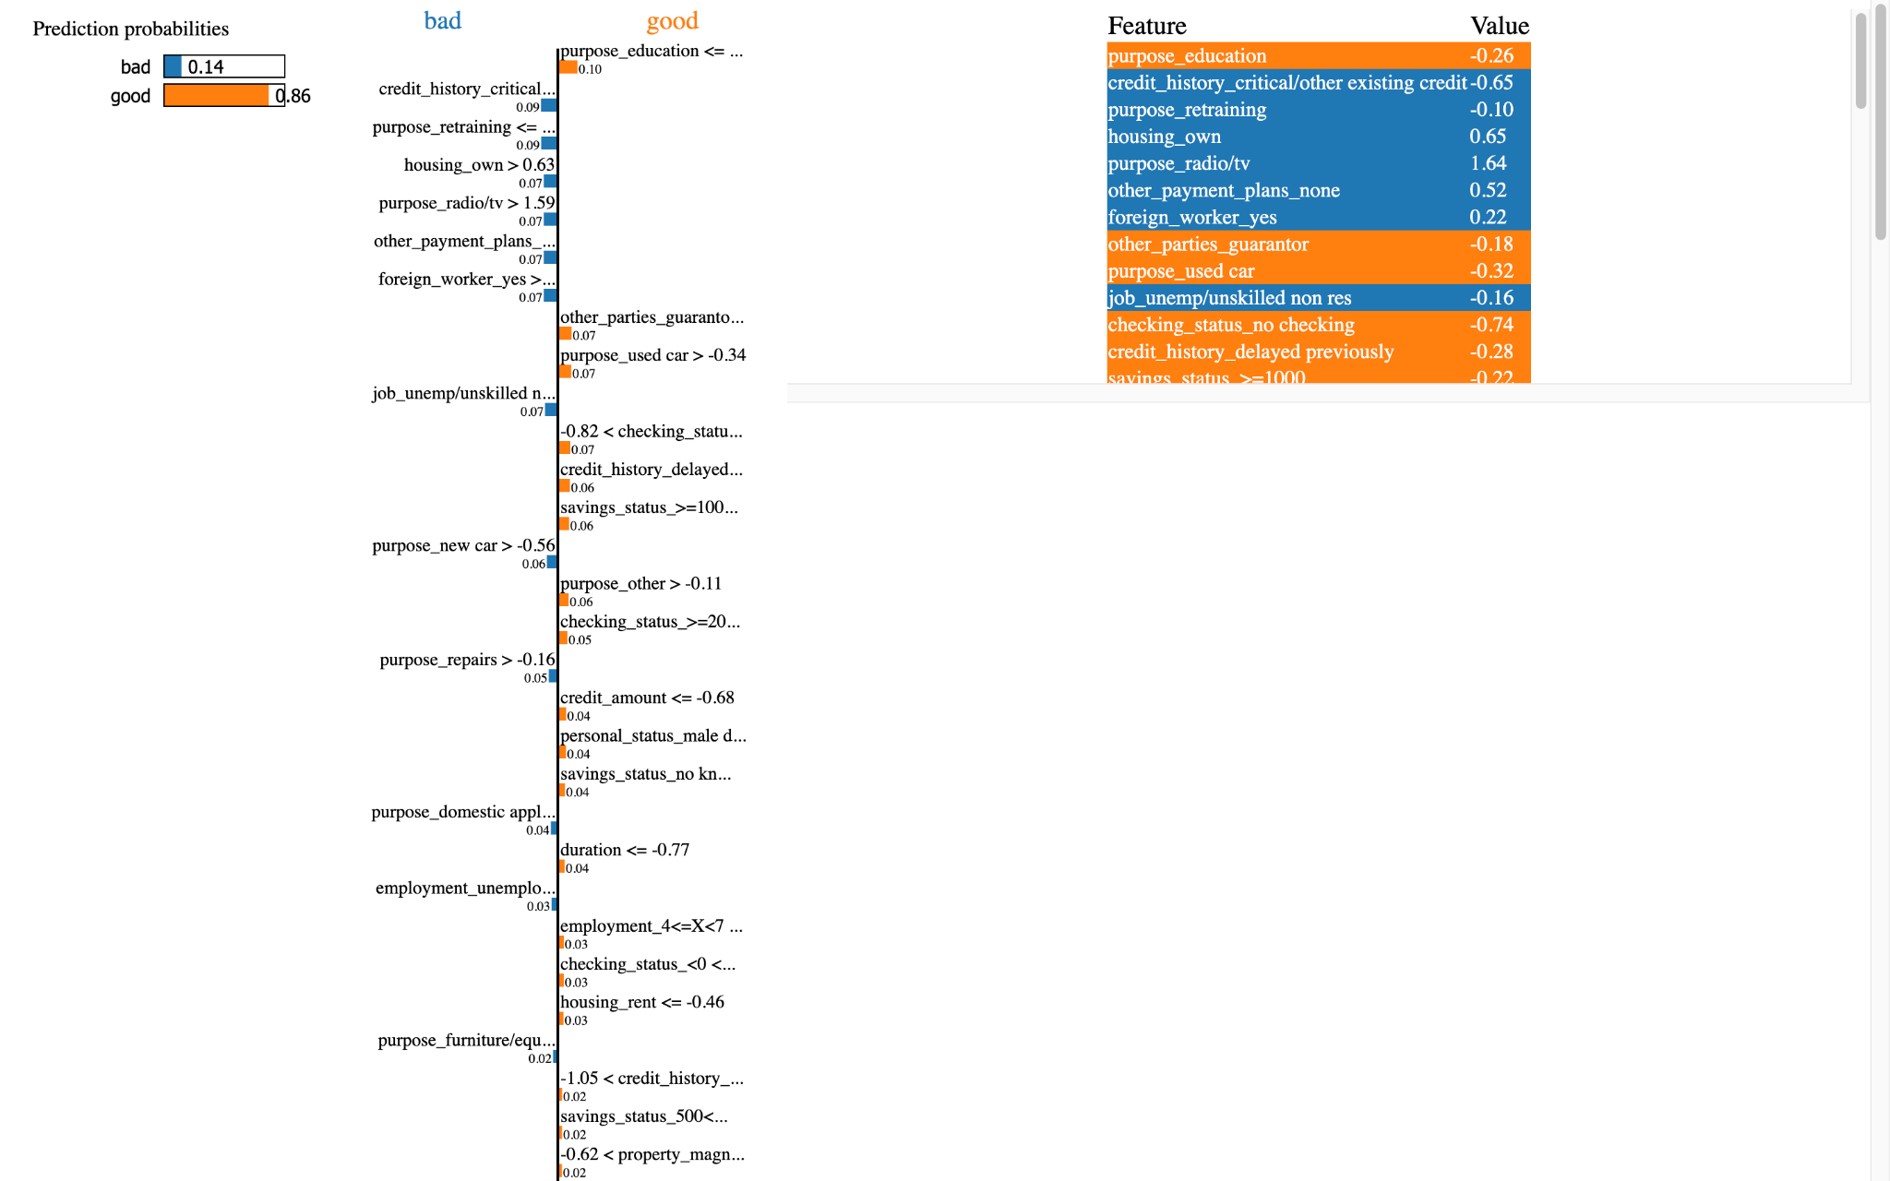

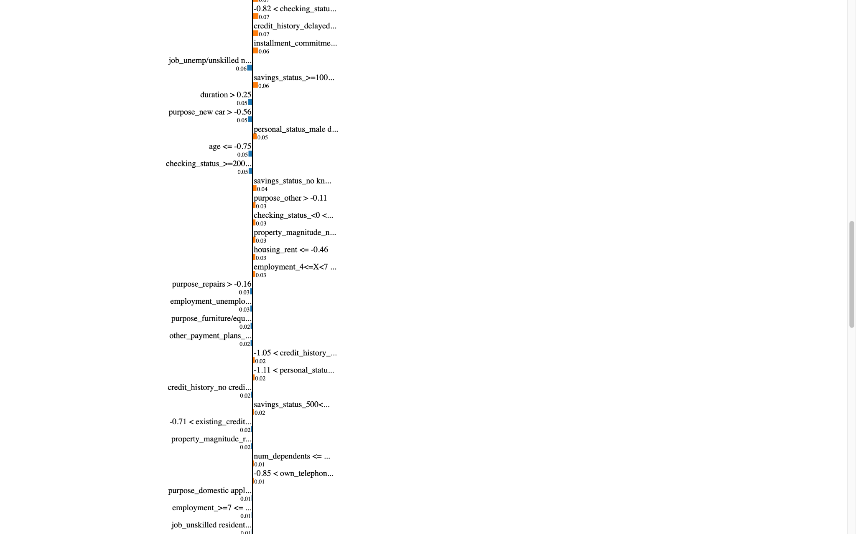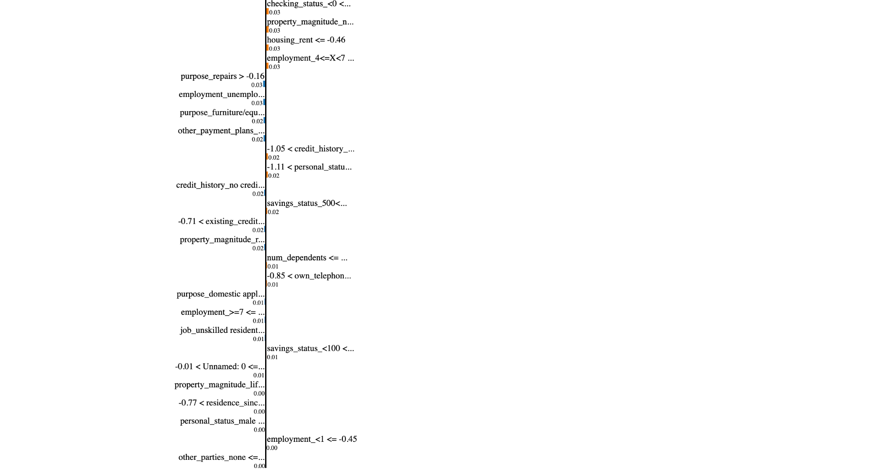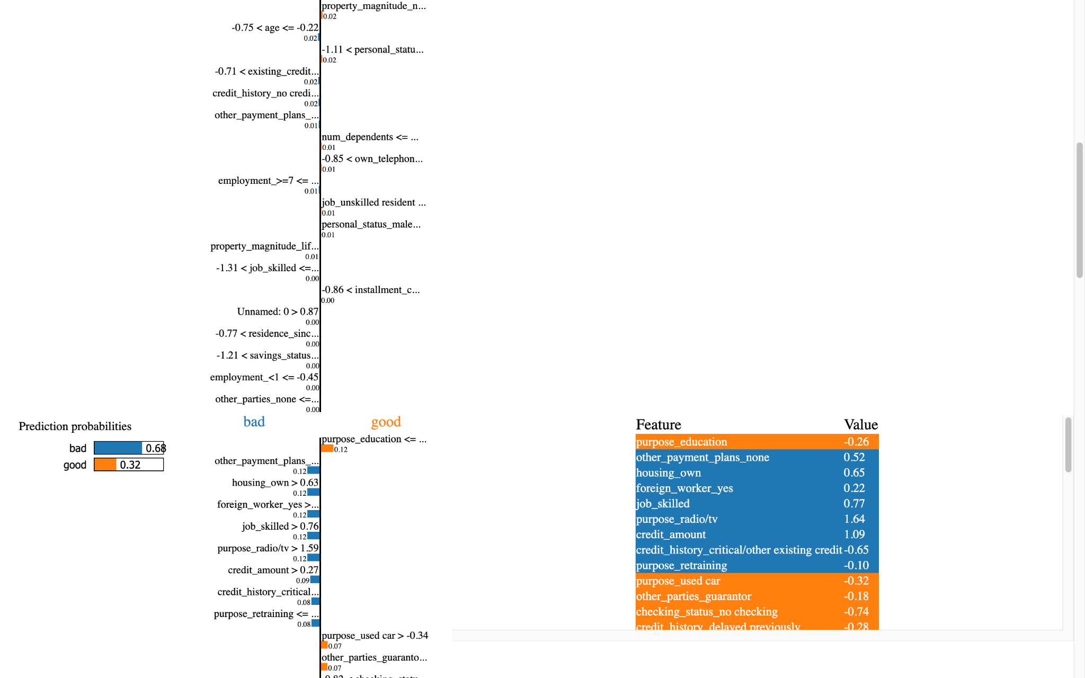

One instance as the plot is long

**Credit Shap:**

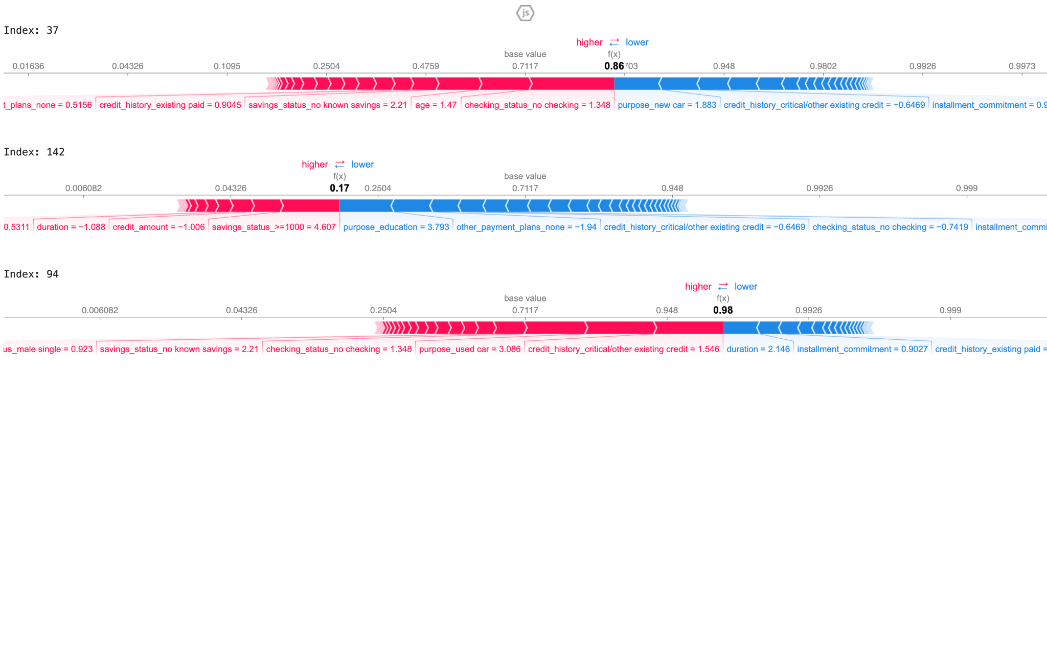

这个summary plot一直报错 改不出来 只能这样的了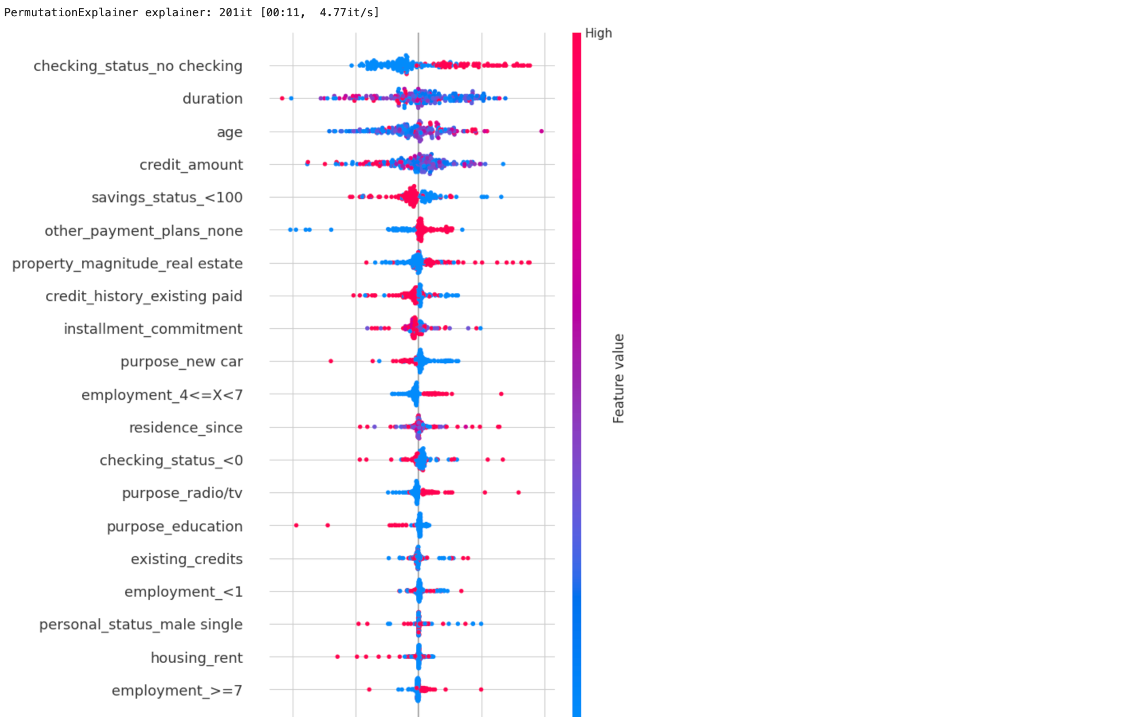

Dataset: btsc

**Btsc Lime:**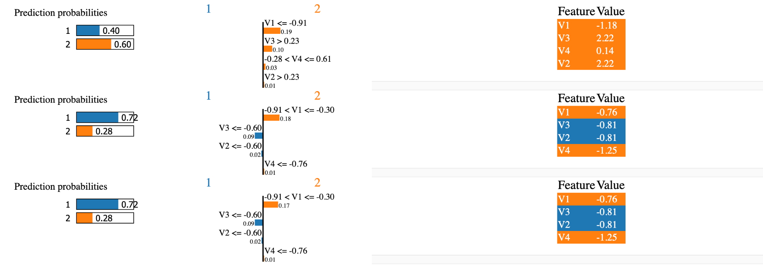

**Btsc Shap:**

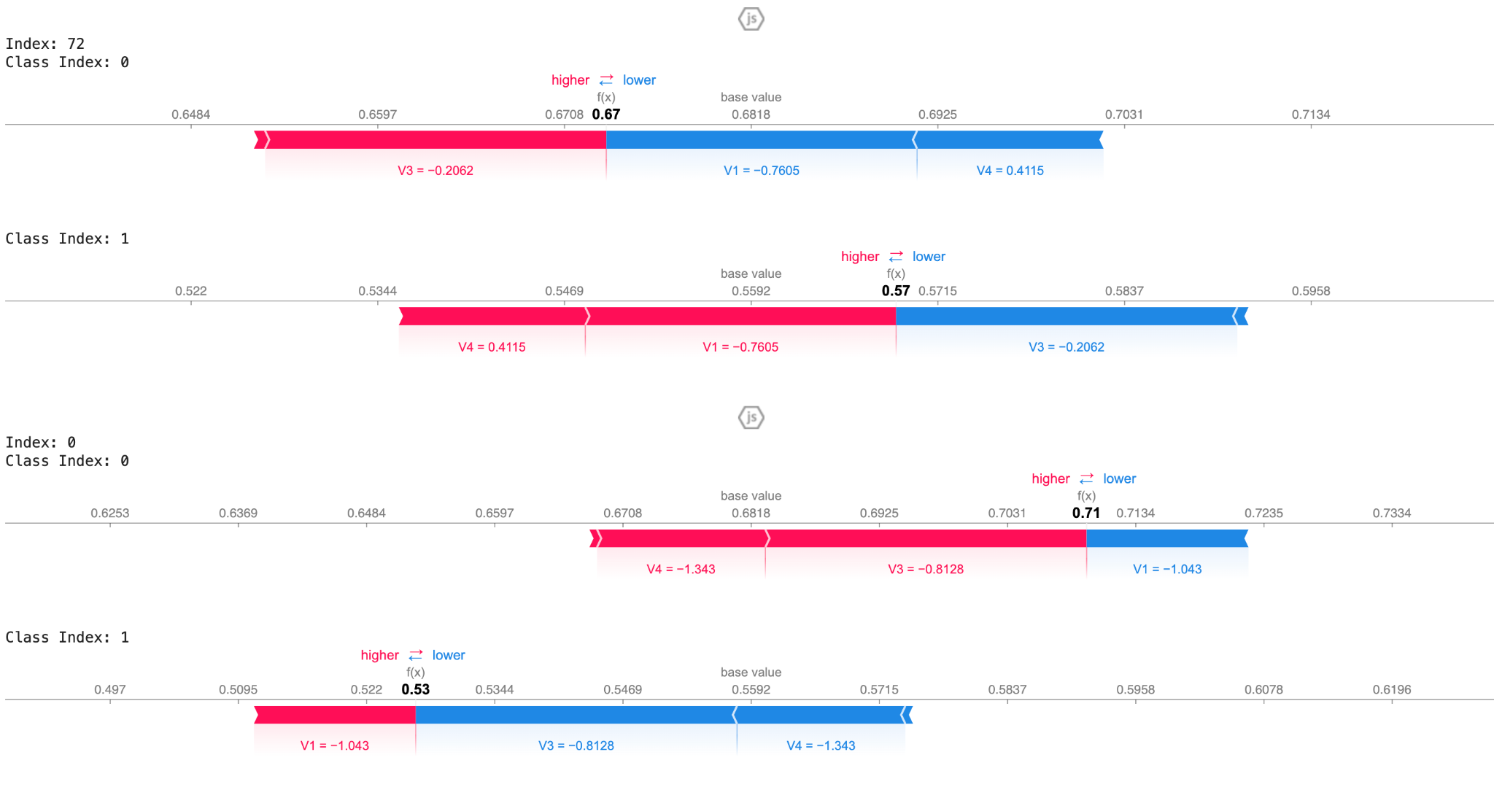

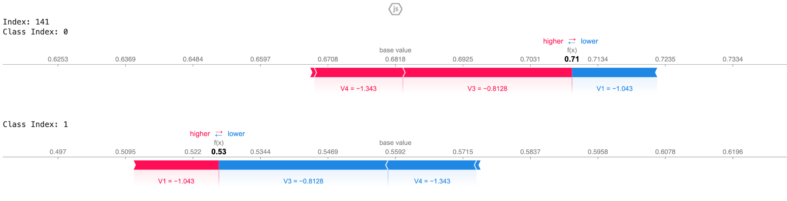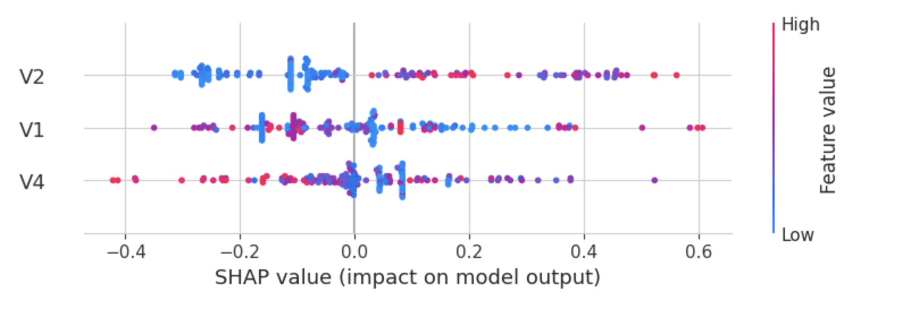

Dataset: Madelon

*Distribution of Some features*

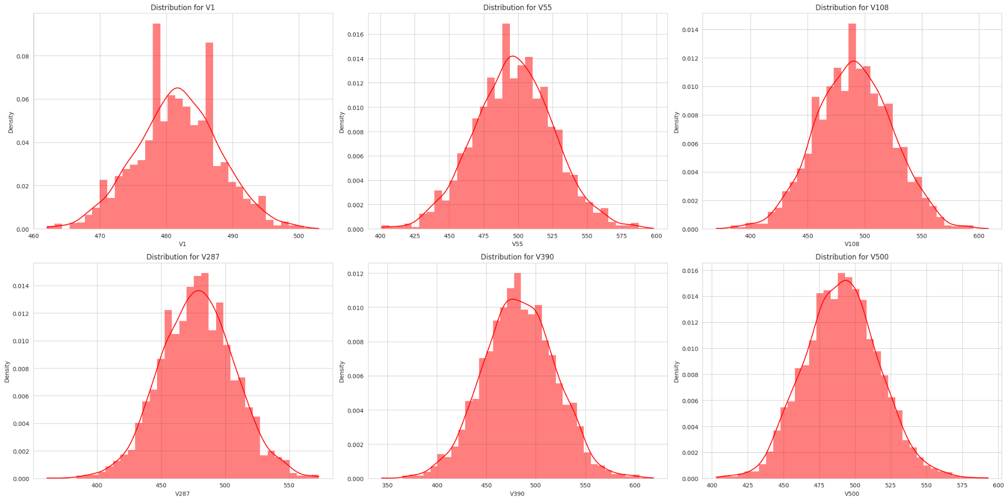

The variables above are normally distributed and are distributed over similar ranges, but still standardized in case other variables that didn't show above are distributed over the different ranges.

*Decision Tree*

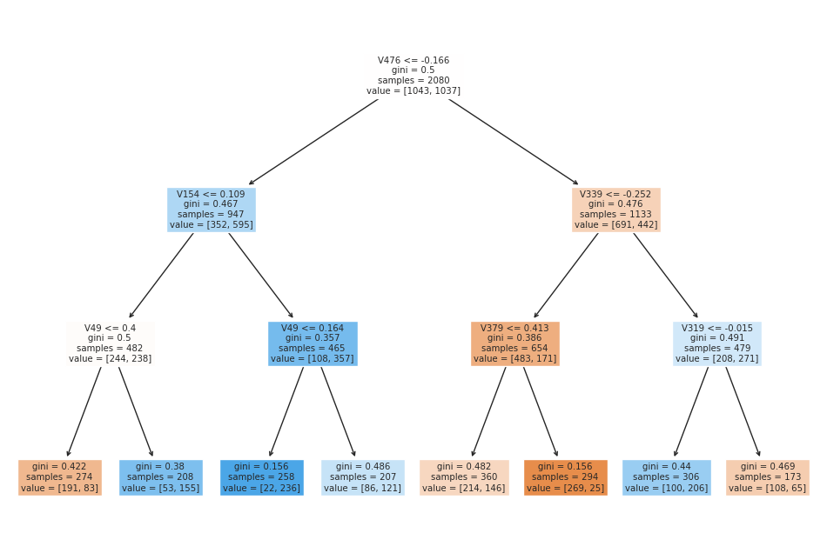

*Neural Network Training Accuracy & Loss*

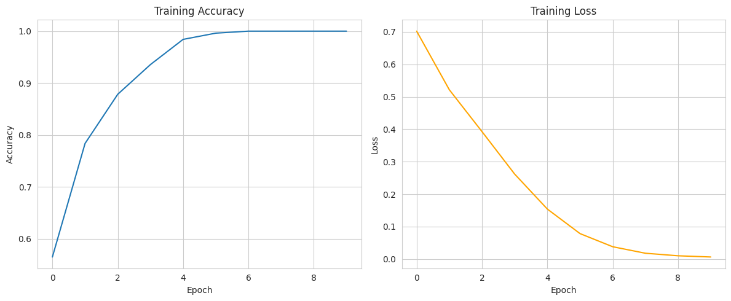

Accuracy increase and loss decrease over epoch, but could be overfitting

*ROC Curve*

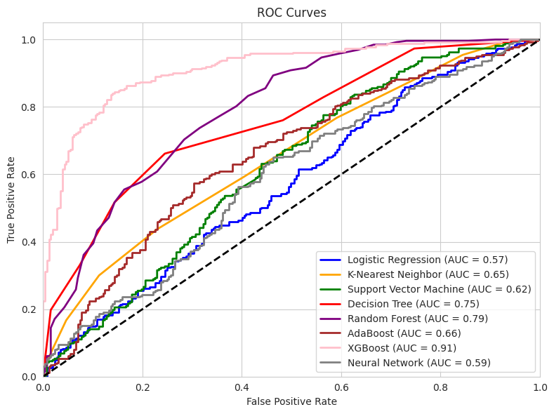

XGBoost has the highest ROC AUC score, and it's significantly higher than other models' scores.

*LIME*

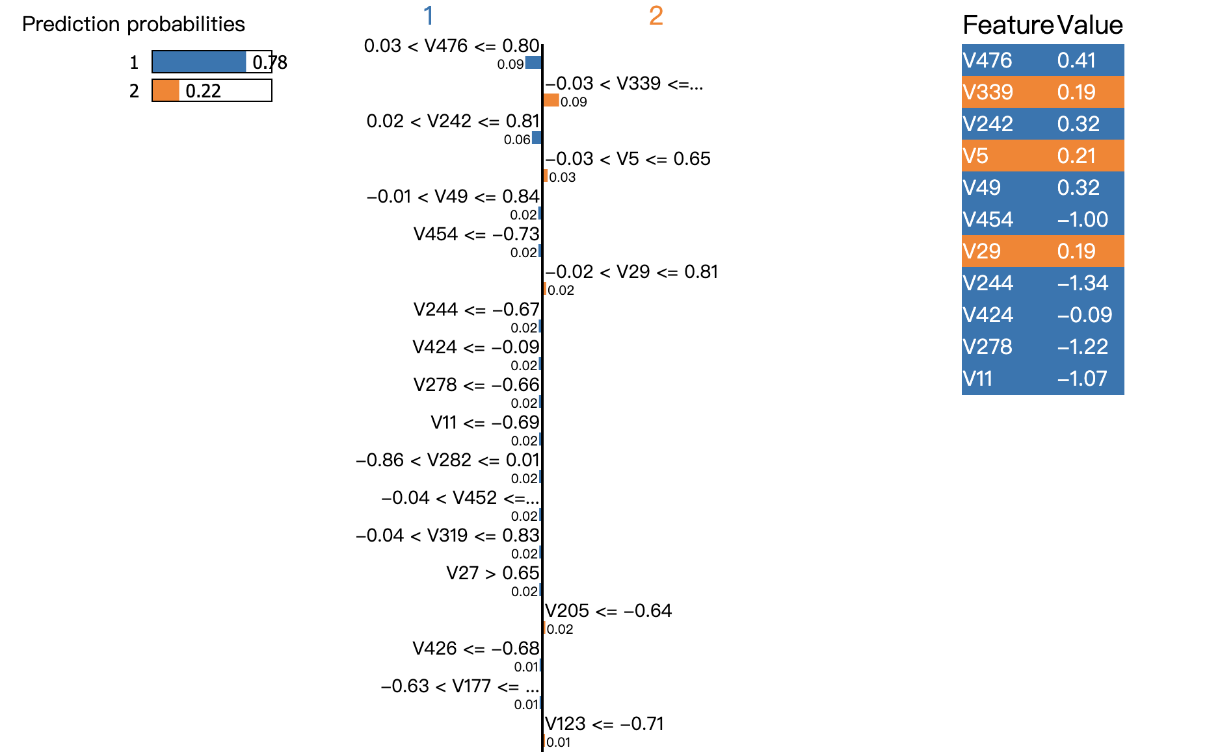

Feature importance score (least 10)

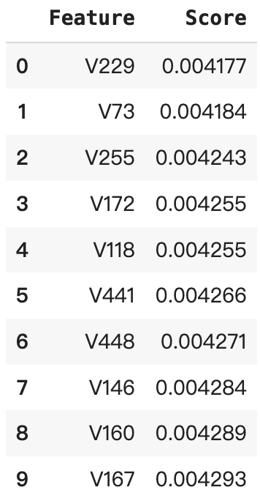

*SHAP (show 3 instance)*

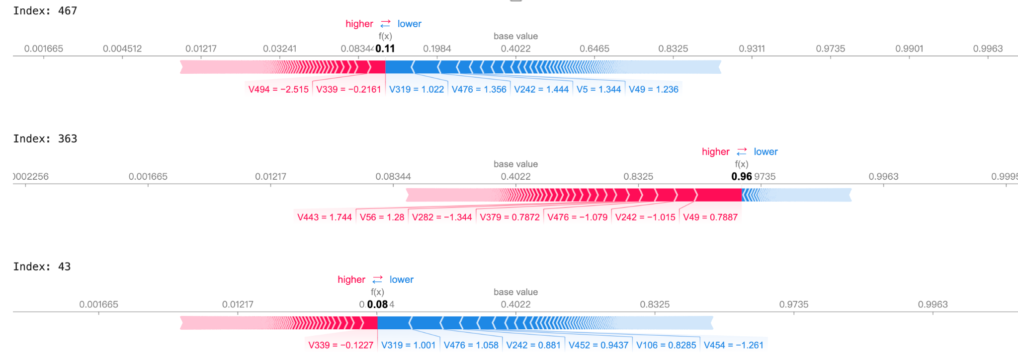

Feature importance score (least 10)

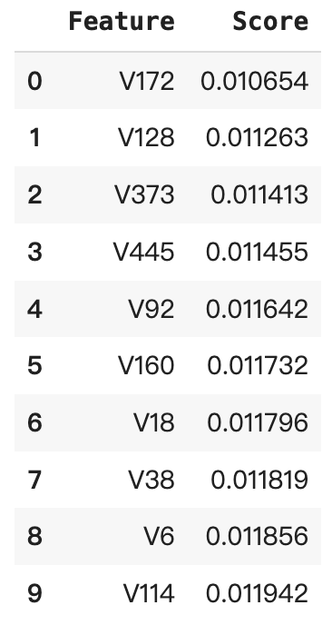

Summary plot

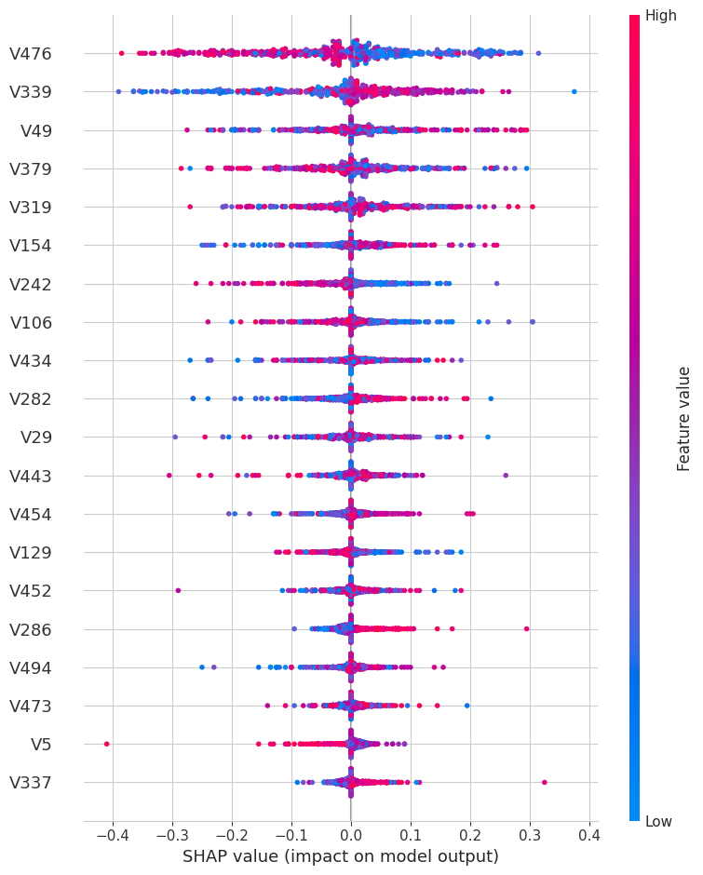

*ROC Curve (After LIME & SHAP)*

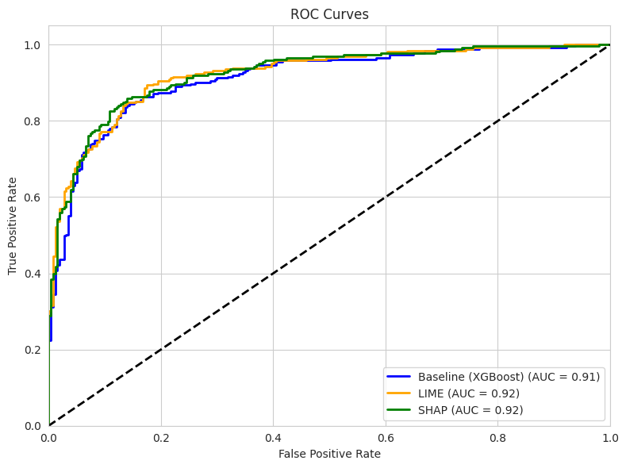

LIME and SHAP did improve model performance on prediction but not significant.

Dataset: wdbc

*Distribution of Some features*

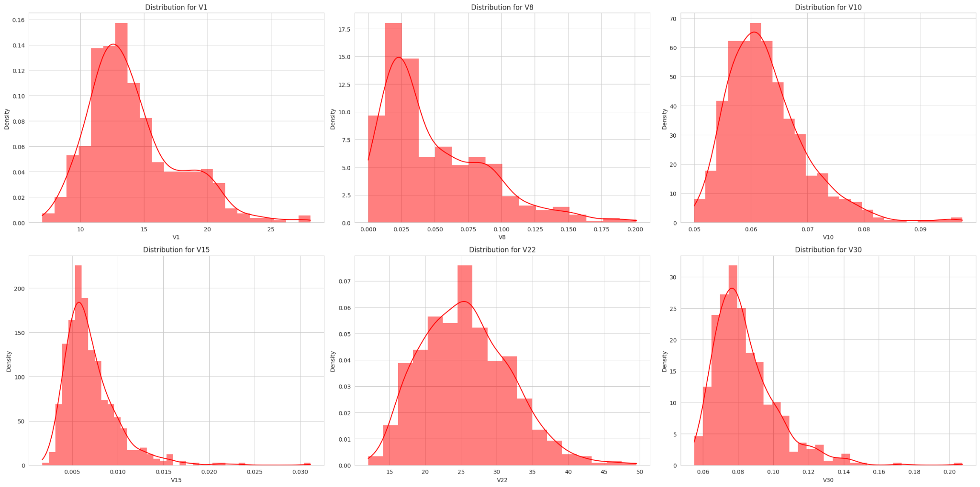

Numerical features are distributed over different value ranges, thus standardization is needed.

*Correlation*

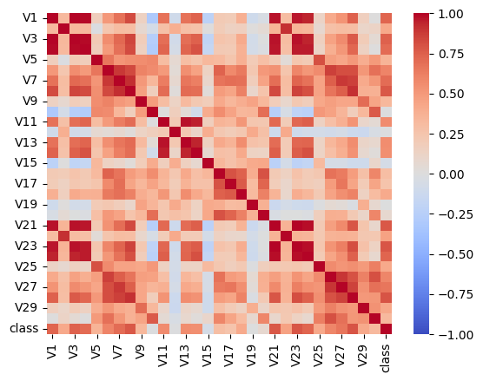

*Decision Tree*

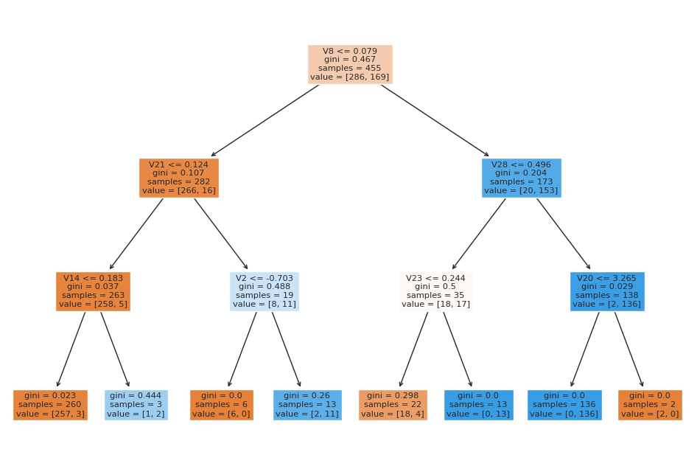

*Neural Network Training Accuracy & Loss*

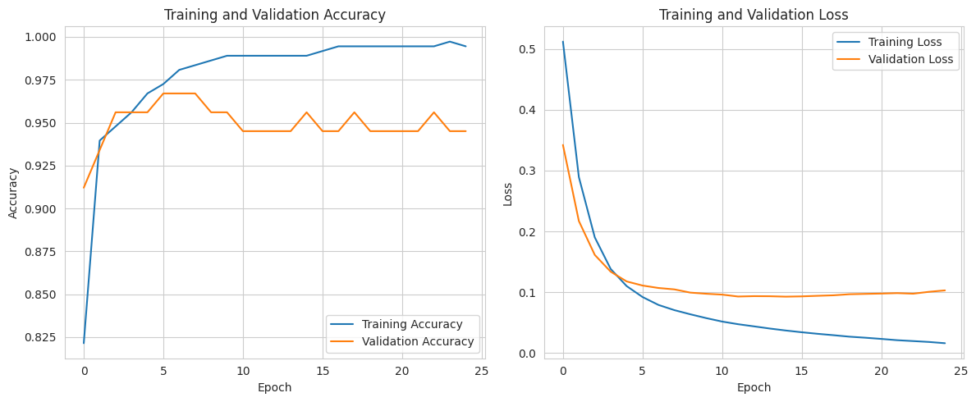

Accuracy increase over epoch. Very small fluctuations for val_accuracy

*ROC Curve*

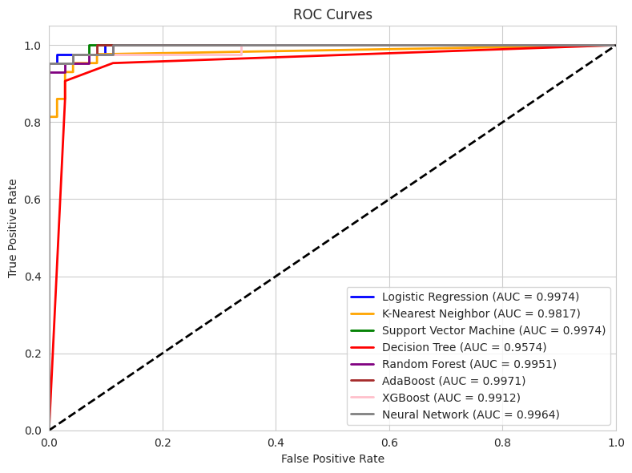

AUC are all very close to 1 (overfitting?)

*LIME*

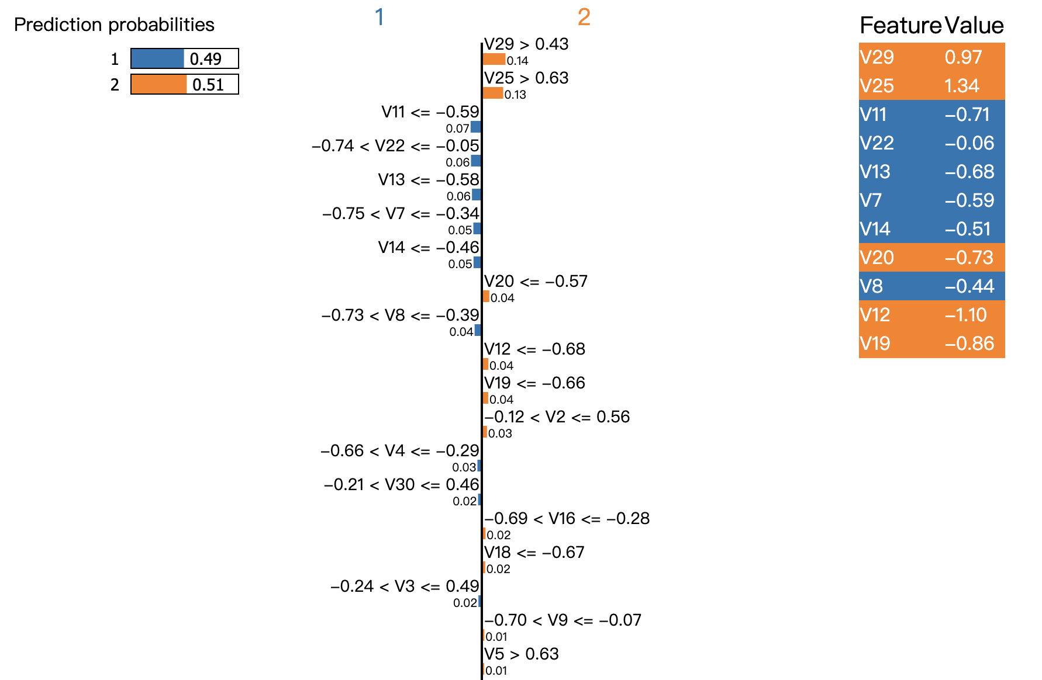

Feature importance by LIME (least 5)

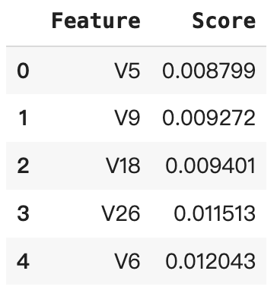

*SHAP*

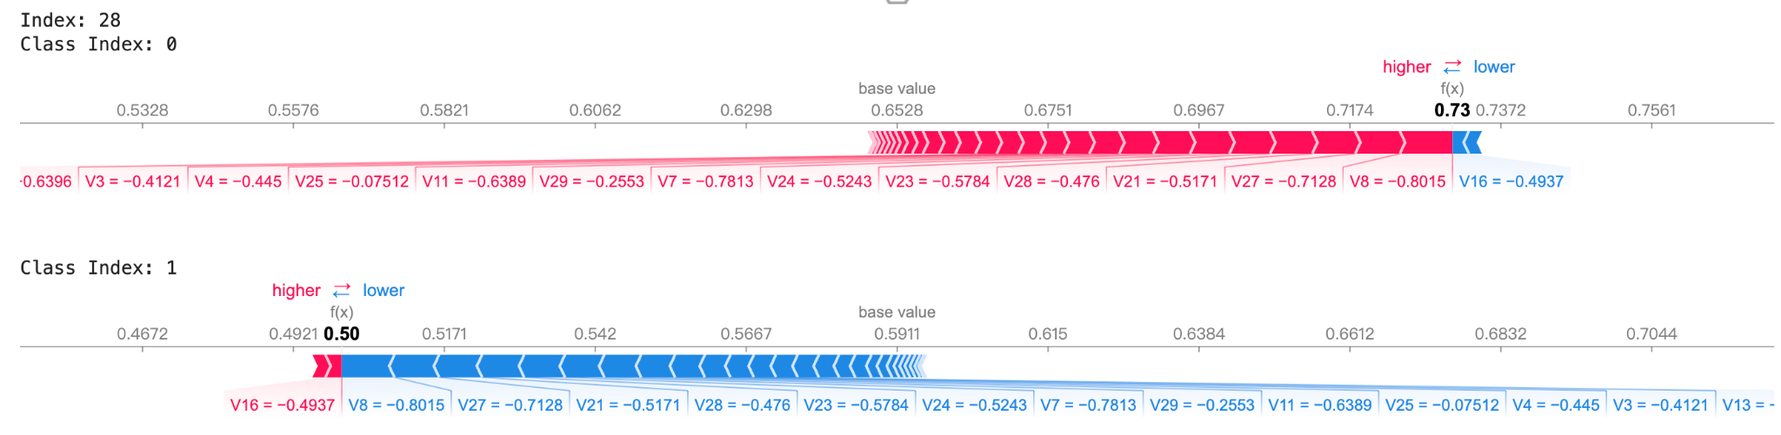

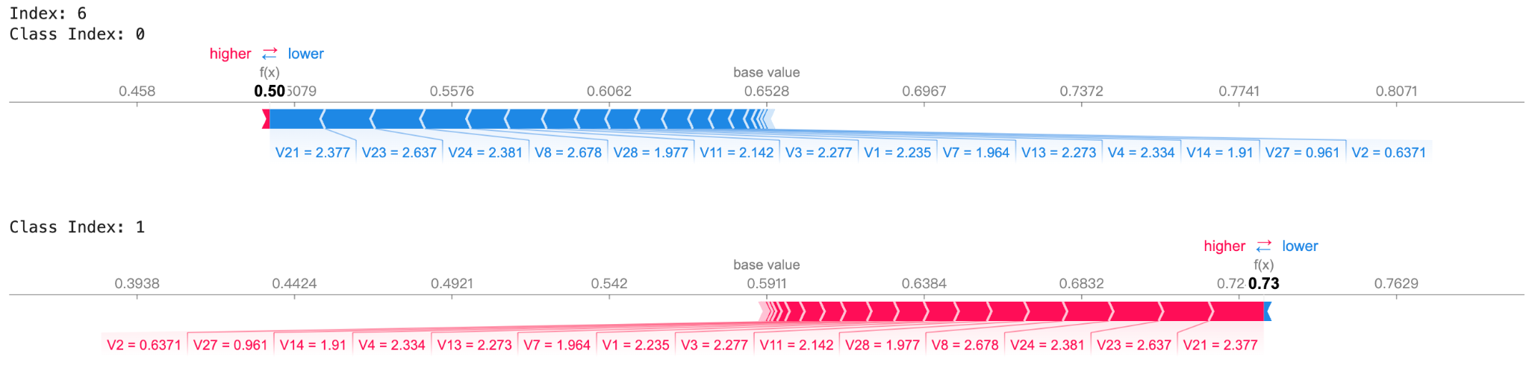

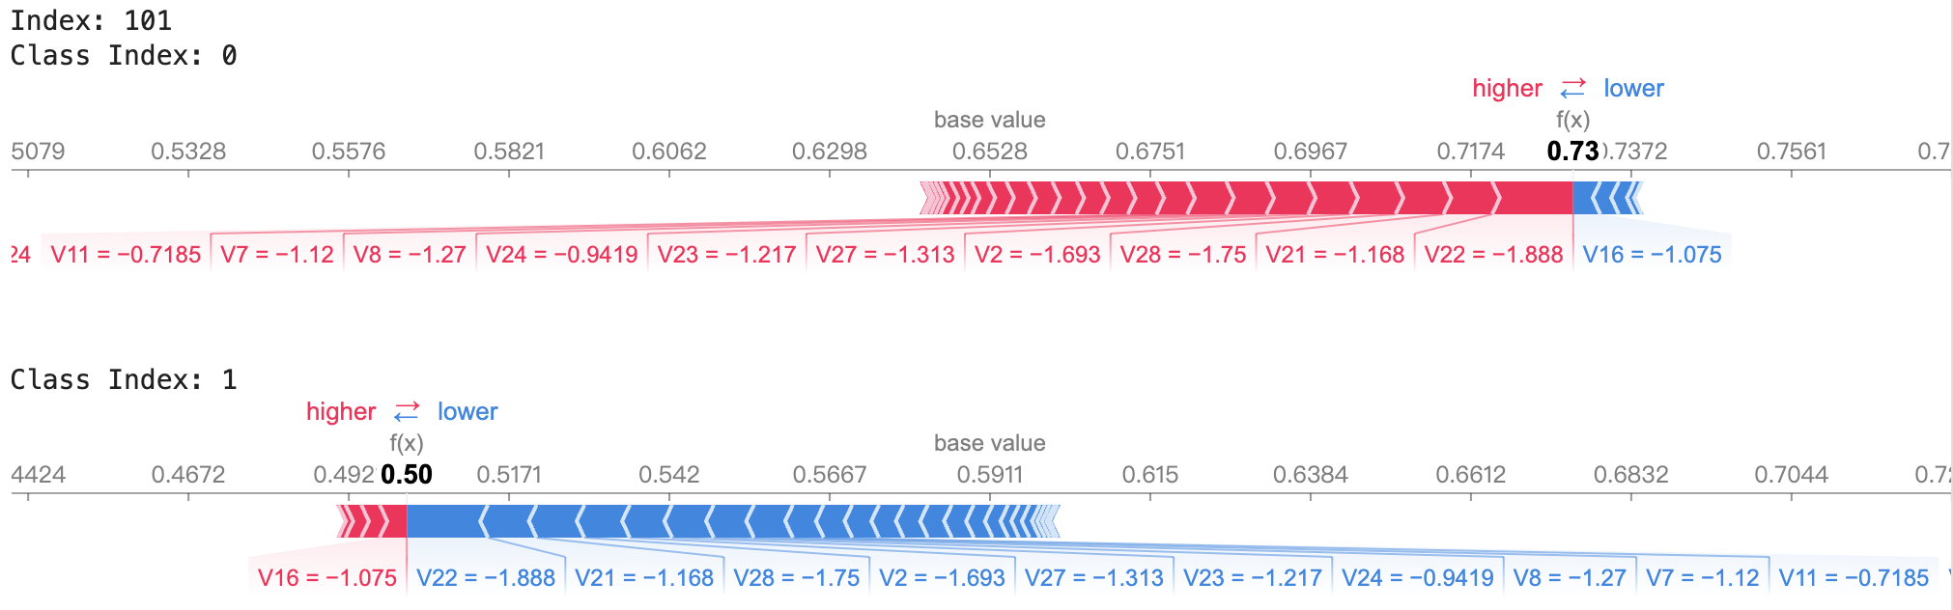

Feature importance by SHAP (least 5)

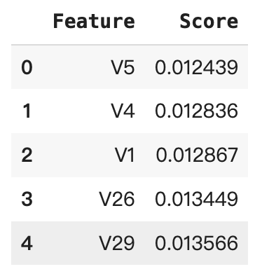

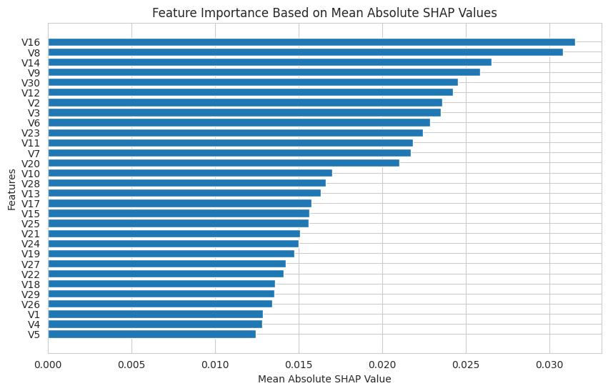

Summary Plot

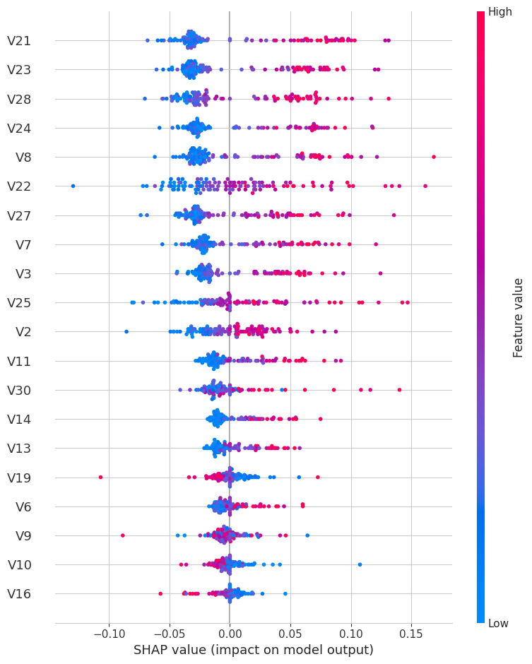

*ROC Curve (After LIME & SHAP)*

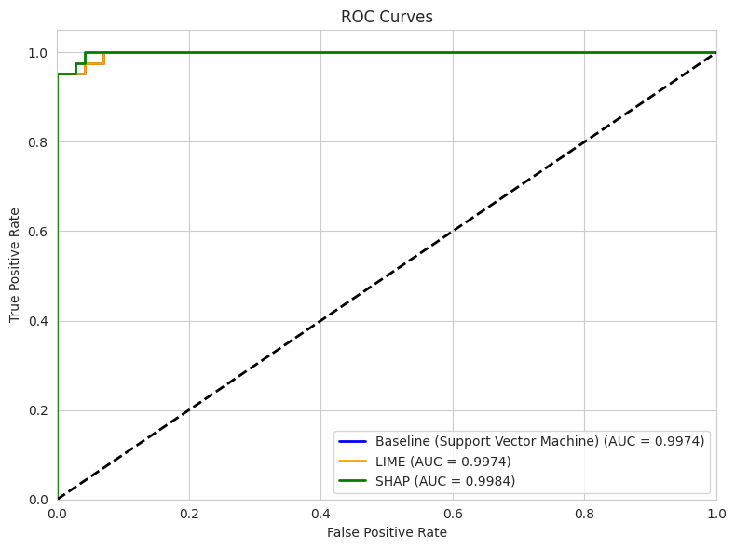

AUC improved a little bit after SHAP adjustment.

Dataset: pc4

*Distribution of features*

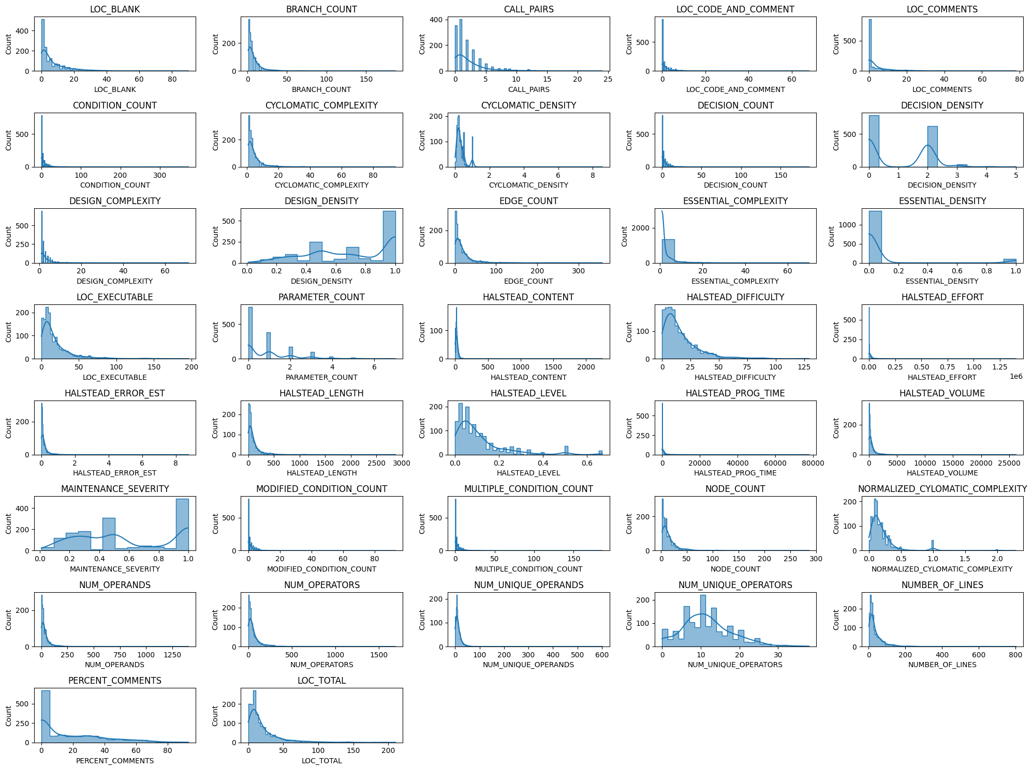

Variables are distributed over different ranges, thus standardization is needed

*Correlation*

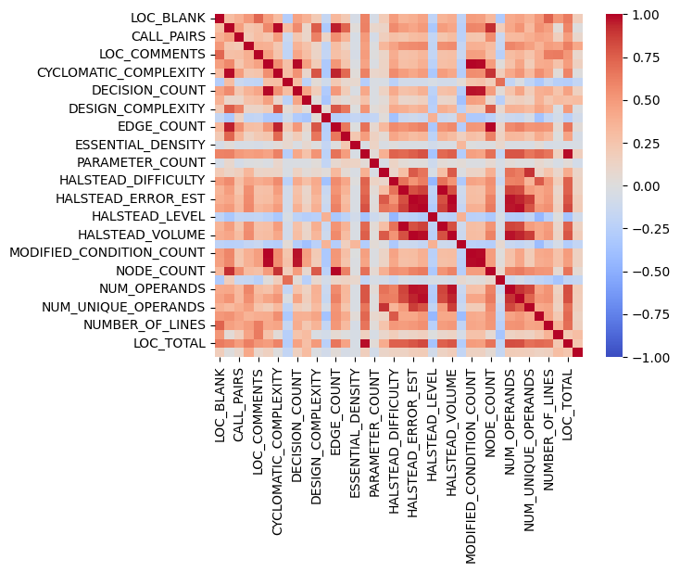

*Decision Tree*

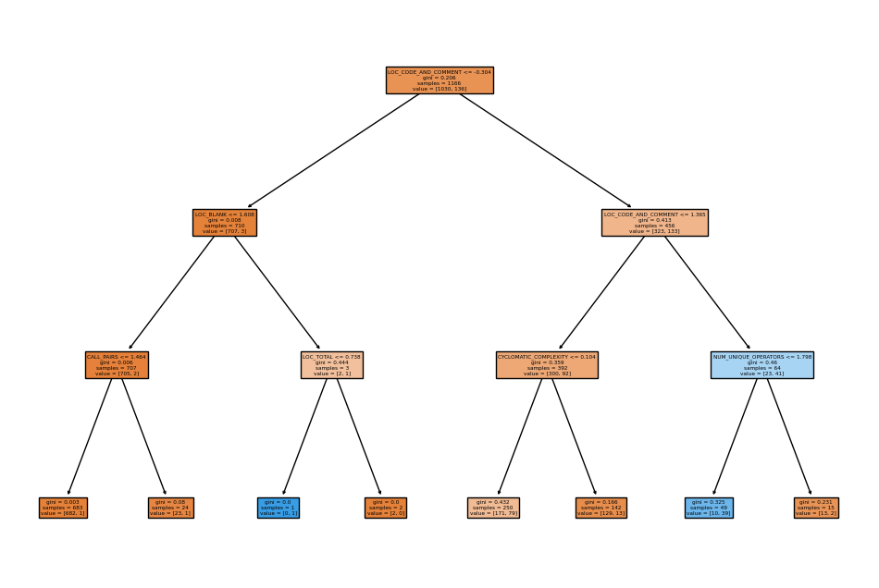

*Neural Network Training and Validation Accuracy & Loss*

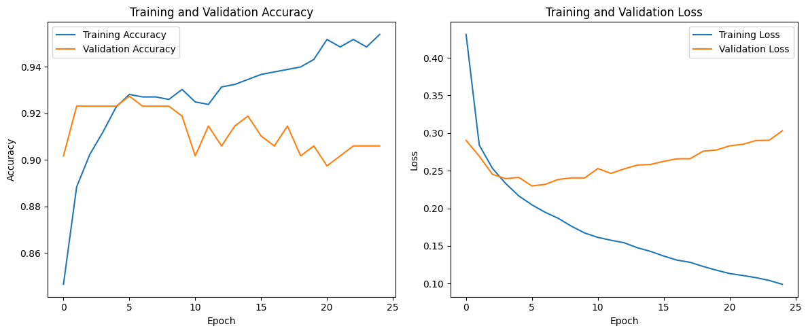

Validation Accuracy decreases a little bit over epoch, could iterate with more epoch in the future to see the trend

*ROC Curve*

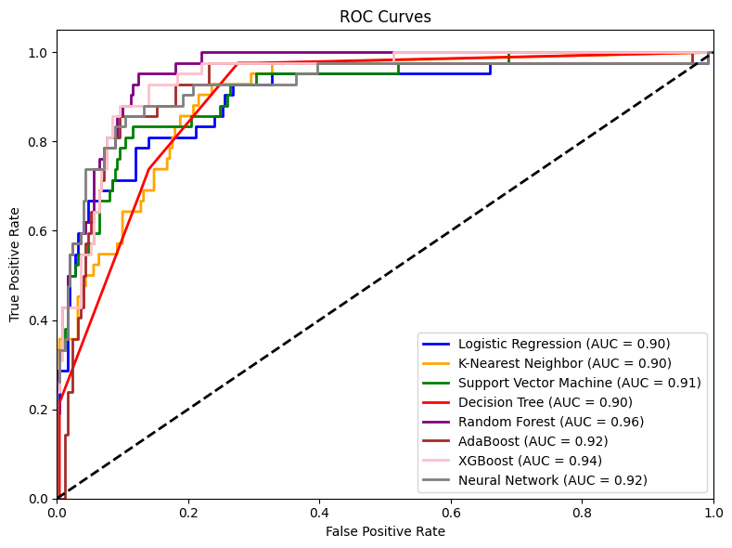

Random Forest has the highest ROC AUC score. All models have similar AUC, so also refer to other metrics when selecting the best model.

*LIME (1 instance since there are too many features displayed)*

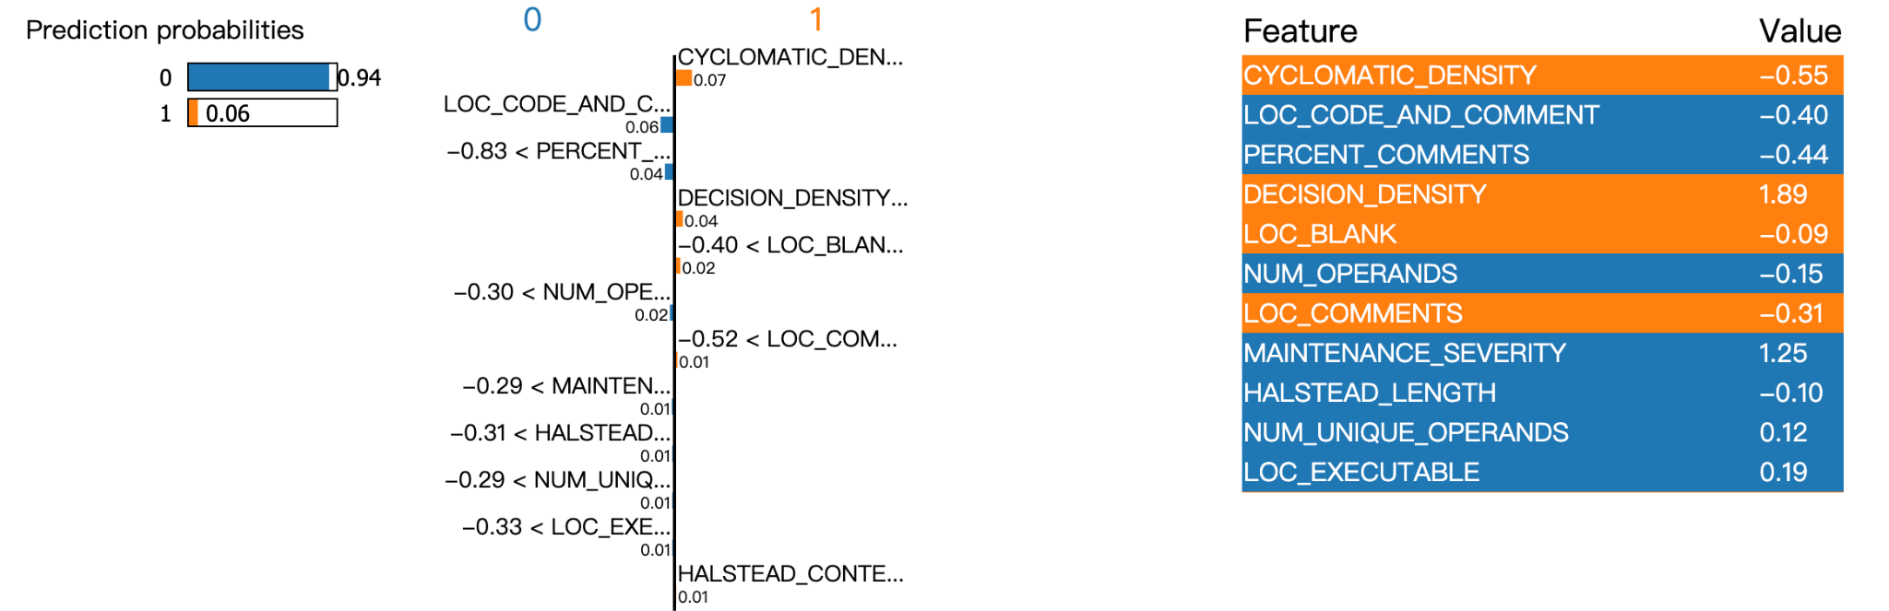

Feature importance score by LIME: least 5

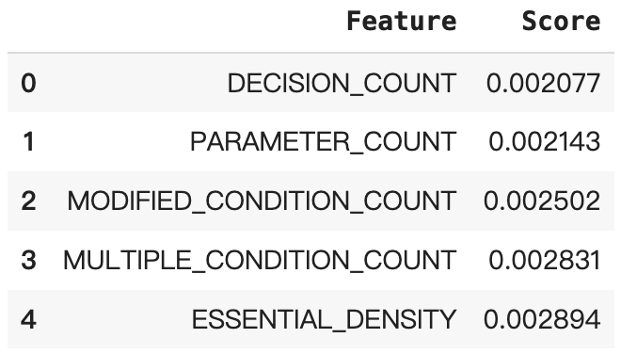

*SHAP (show 3 instances)*

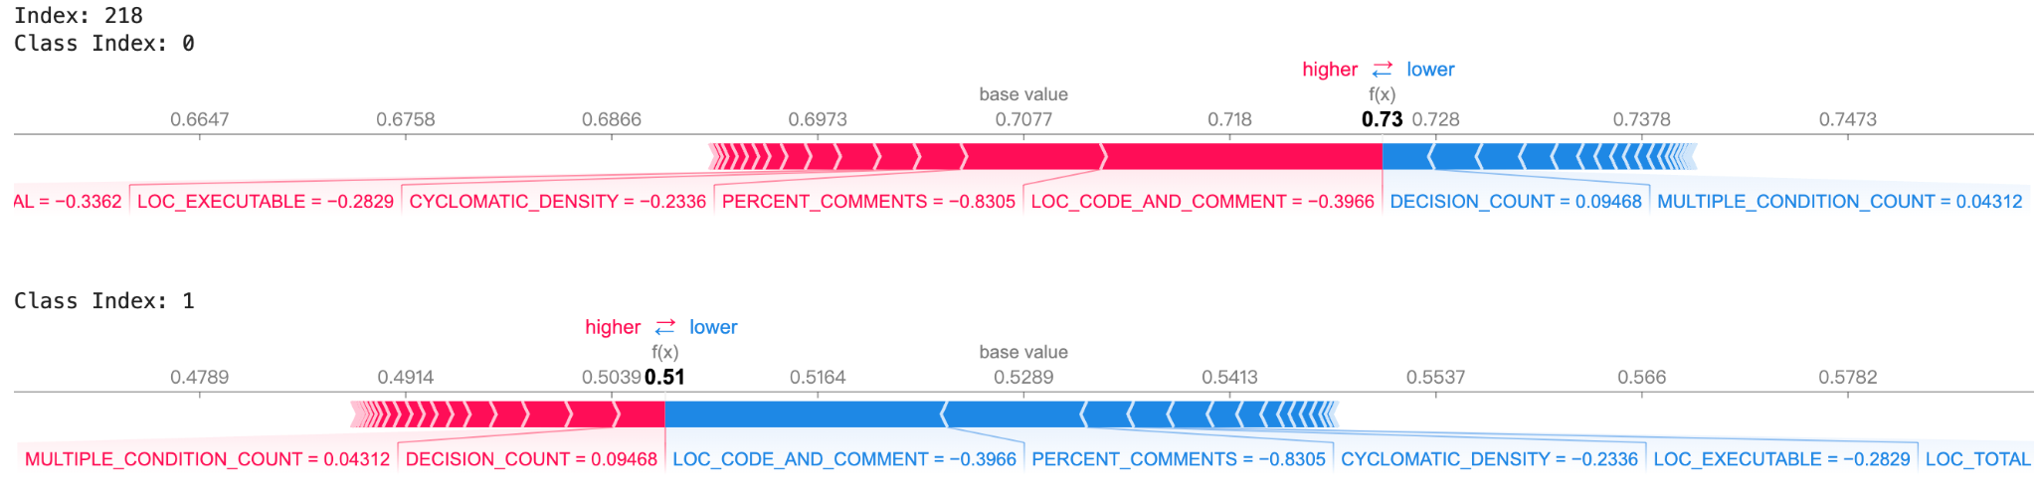

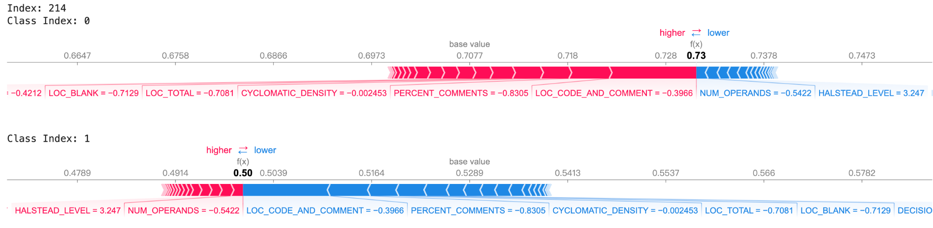

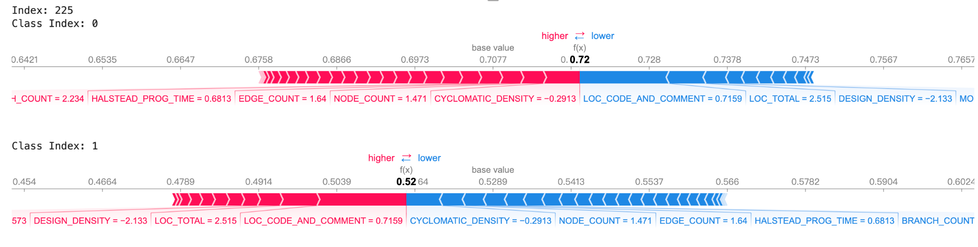

Feature importance by SHAP

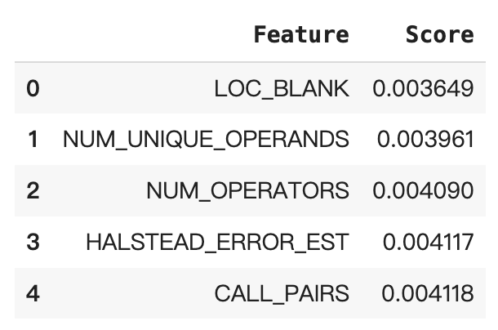

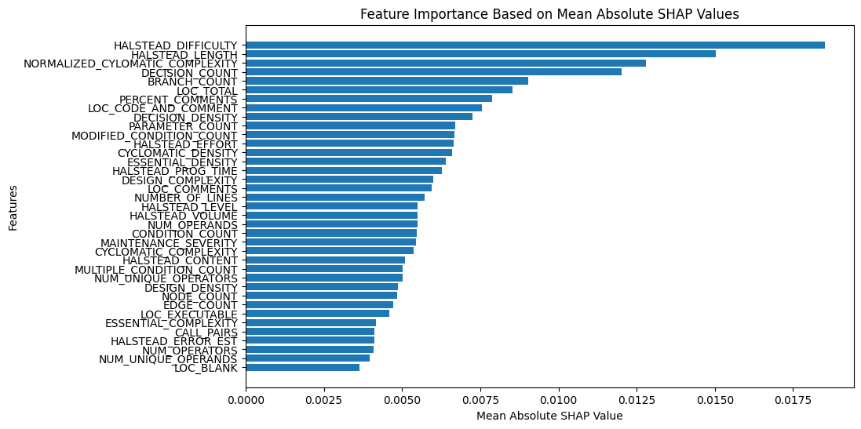

Summary plot

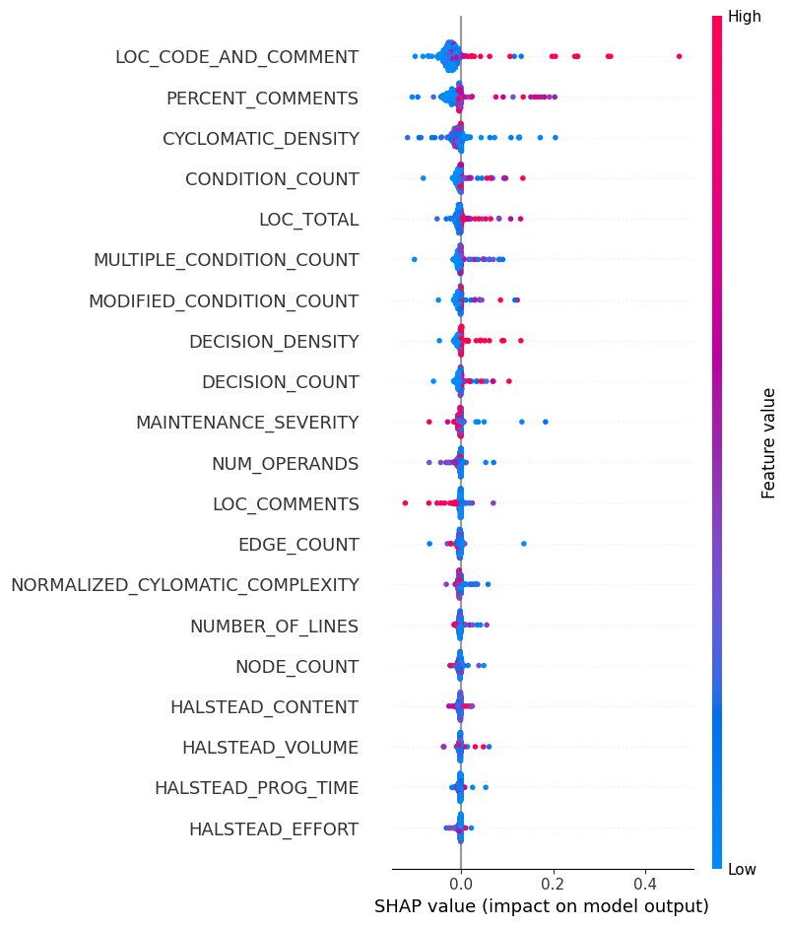

*ROC Curve (After LIME & SHAP)*

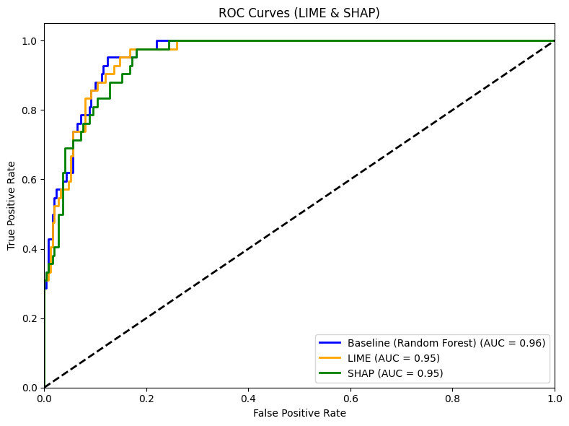

Dataset: scene

*Correlation (too many features so visualize some of features)*

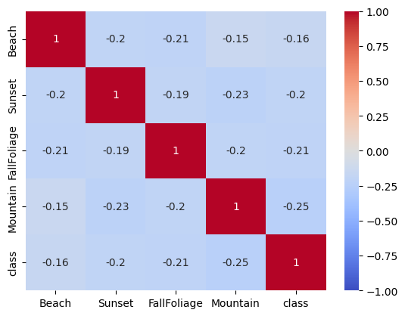

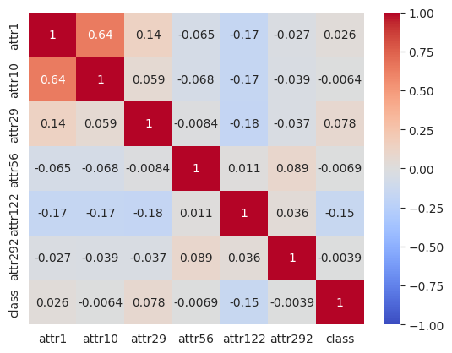

*Distribution of Some features*

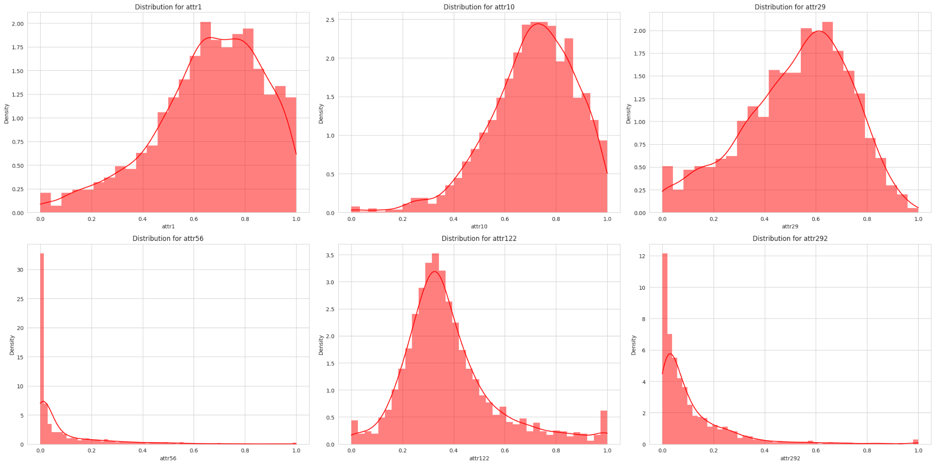

Attributes are distributed in the same range (0, 1), and other features are binary, so we don't need further standardization, but transformation is needed for skewed attributes.

*Decision Tree*

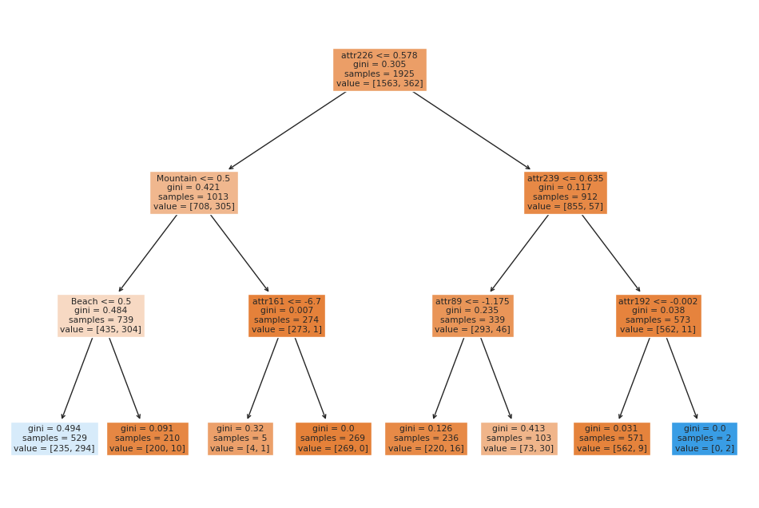

*Neural Network Training Accuracy & Loss*

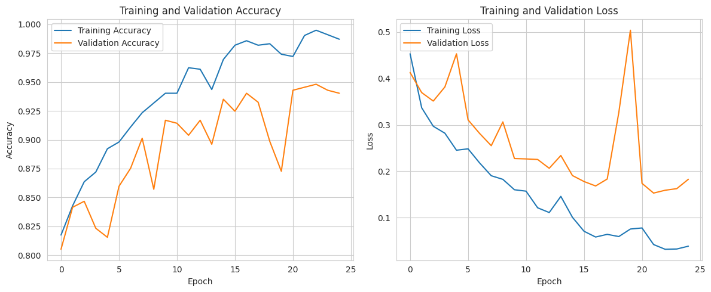

Accuracy increases over epoch

*ROC Curve*

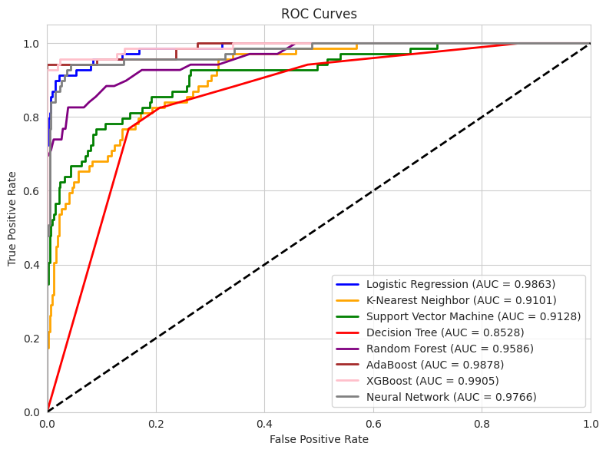

XGBoost has the highest ROC AUC score

*LIME*

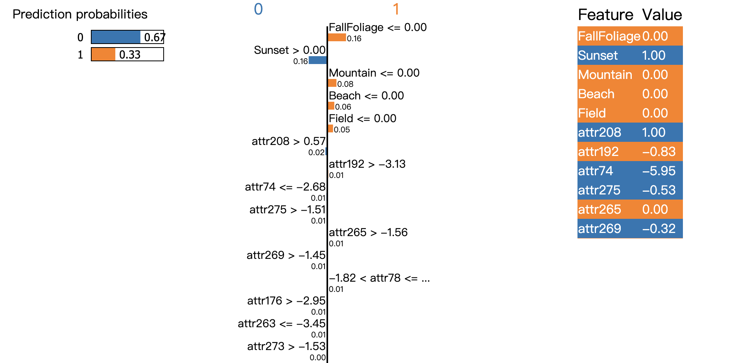

Feature importance by LIME (least 10)

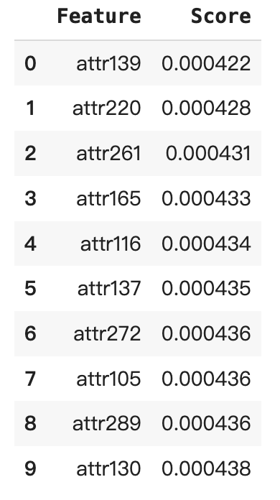

*SHAP*

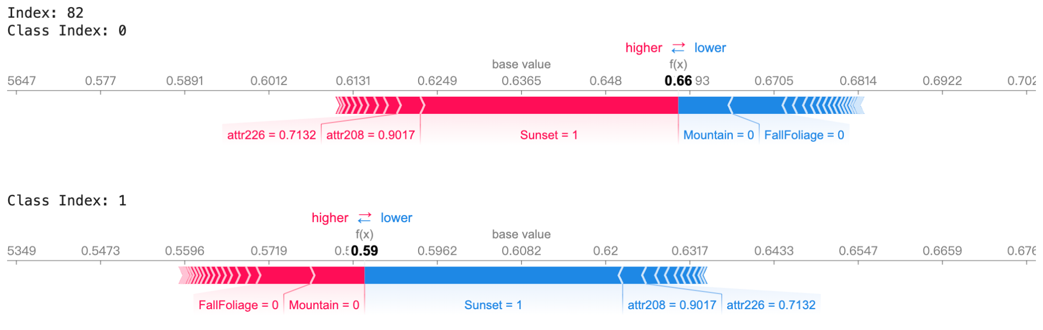

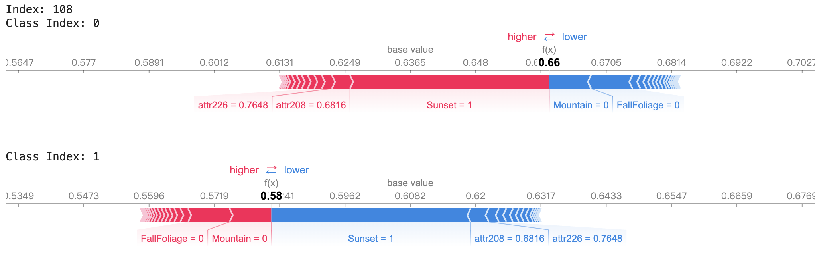

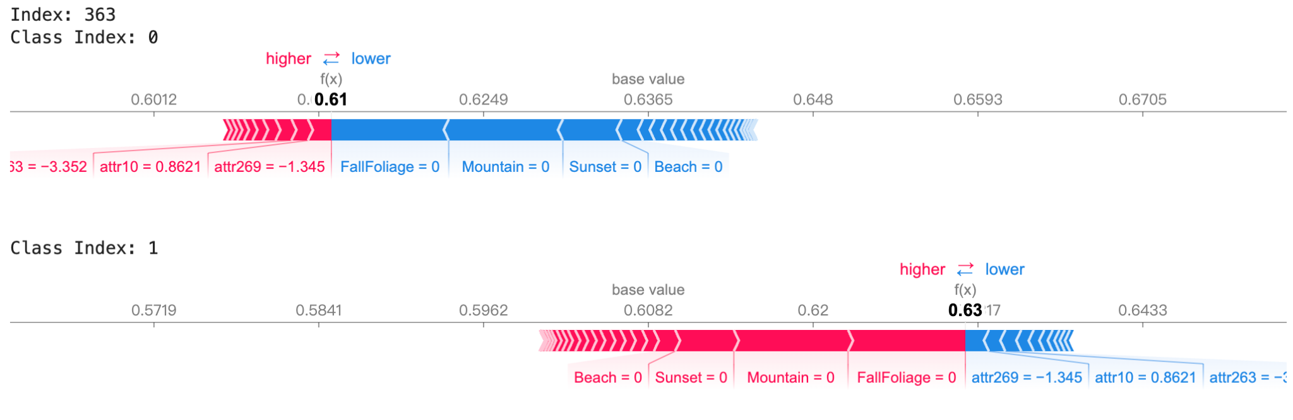

Feature importance by SHAP (least 10)

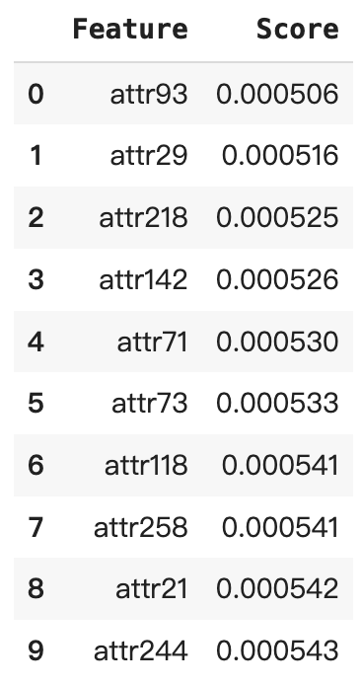

Summary plot

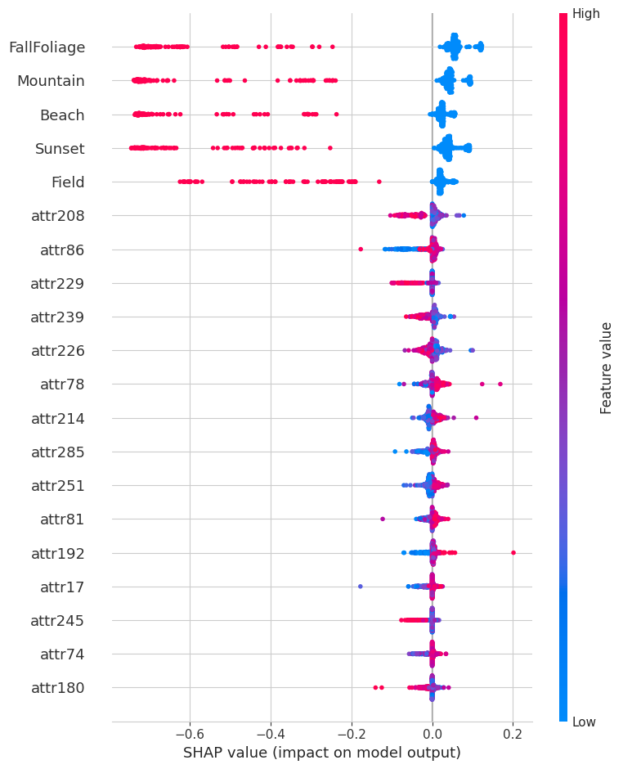

*ROC Curve (After LIME & SHAP)*

